**A northeast United States Atlantis marine ecosystem model with ocean reanalysis and ocean color forcing**

Joseph C. Caracappa1, Andrew Beet2, Sarah Gaichas1, Robert J. Gamble1, Kimberly J.W. Hyde3, Scott I. Large1, Ryan E. Morse3, Charles A. Stock4, Vincent S. Saba5

1 NOAA Northeast Fisheries Science Center, 166 Water Street, Woods Hole, MA, USA 02543.

2IBSS in support of Northeast Fisheries Science Center, National Marine Fisheries Service, National Oceanic and Atmospheric Administration, Woods Hole, Massachusetts, USA

3 NOAA Northeast Fisheries Science Center, 28 Tarzwell Drive, Narragansett, RI, USA, 02882

4 ECS Federal LLC in support of Office of Science and Technology, National Marine Fisheries Service, National Oceanic and Atmospheric Administration, Woods Hole, Massachusetts, USA

5 NOAA Geophysical Fluid Dynamics Laboratory, Princeton University Forrestal Campus, 201 Forrestal Road, Princeton, NJ, USA 08540.

6 NOAA Northeast Fisheries Science Center, Geophysical Fluid Dynamics Laboratory, Princeton University Forrestal Campus, 201 Forrestal Road, Princeton, NJ, USA 08540.

Abstract

The northeast United States Atlantis model (NEUSv2) is an end-to-end ecosystem model that can simulate biogeochemical, ecological, fishery, management, and socio-economic processes within marine ecosystems. As a major update to the original model, NEUSv2 includes changes to the model’s functional group definitions and forcing data. NEUSv2 is the first Atlantis model to use a satellite-based phytoplankton size-class model to force marine primary production. This model was regionally tuned using ocean color data. Additionally, physical ocean variables (currents, temperature, and salinity) were newly updated using a high-resolution global ocean reanalysis. Despite its coarse resolution, NEUSv2 was capable of reproducing the spatial and seasonal patterns seen in the physical and biological forcing sources, with the exception of some circulation features. NEUSv2 was also able to reproduce observed levels of domain-wide zooplankton biomass, the relative abundance of zooplankton and planktivore species, and the recent shifts in zooplankton community structure. NEUSv2 now meets calibration criteria for the persistence and long-term stability of functional group biomass. Given the success of this new Atlantis forcing approach, we detail the observations and challenges we encountered with a focus on spatial delineations, data processing, and biological calibration. As it stands, NEUSv2 is well suited for investigating the implications of simulated biogeochemical and plankton dynamics from other biogeochemical models on broader ecosystem processes. Future work will involve improving the higher trophic level and socioeconomic processes with the intent of producing projections under climate change scenarios.

Keywords: Atlantis, marine ecosystem models, end-to-end models, biogeochemical forcing, primary production, global reanalysis, ocean color, lower trophic levels

Highlights:

* NEUSv2 is the first Atlantis model to successfully force primary production with a satellite-based ocean color model.
* NEUSv2 is a major update to the Northeast United States Atlantis model.
* NEUSv2 was capable of reproducing the spatial patterns and seasonality of both the phytoplankton and physical forcing sources, as well as a realistic lower trophic food web.
* NEUSv2 was able to meet baseline calibration criteria with these new forcing variables.
* We describe our experience with this new method with a focus on model definitions, data processing, and calibrations.

1. Introduction

Atlantis is an end-to-end ecosystem model that can simulate biogeochemical, ecological, fishery, management, and socio-economic processes within marine ecosystems (Fulton et al., 2011). Regional Atlantis models have been used around the world to better understand a variety of regional ecosystem processes (100s-1000s km) involving fisheries management strategies (Kaplan et al., 2020; Nilsen et al., 2020), the effects of local stressors (Ihde and Townsend, 2017), as well as regional impacts of climate change (Hodgson et al., 2018; Ortega-Cisneros et al., 2018). Atlantis hindcasts allow analysis of historical patterns and the effects of environmental drivers on marine ecosystems. Atlantis multi-decadal projections can provide valuable strategic management tools and have been used to simulate potential outcomes of ecosystem-based management strategies and the response of regional ecosystems to climate change (Bossier et al., 2021; Hansen et al., 2019; Ortega-Cisneros et al., 2018). A hindcast that reproduces contemporary ecosystem conditions well is critical for building confidence in Atlantis projections (Cheung et al., 2016).

The northeast United States Atlantis model (NEUS), has undergone significant change since its original publication, thus designating a second iteration of the model (NEUSv2). NEUSv2 resolves ecosystem processes within large (~100s km2) polygons (boxes) spanning the continental shelf from Cape Hatteras through the Gulf of Maine (Figure 1; Link et al., 2010). These boxes are delineated based on a variety of factors, including habitat types, bathymetry, hydrography, and fisheries management areas. NEUSv2 simulates the growth, reproduction, migrations, and trophic interactions of functional groups that encompass benthic and pelagic species from plankton to whales. Major changes since NEUSv1 (Link et al., 2011, 2010), include a new code base, functional group definitions (Appendix B), and new physical and biological forcing.

As part of this contribution, NEUSv2’s physical ocean forcing (advection, temperature, and salinity) source was updated to the high-resolution (8.3-km) Copernicus Marine Service’s GLORYS12V1 global reanalysis model (CMEMS, 2018) with vertical advection derived from NASA’s ECCOV4 model (ECCO Consortium, 2015). Furthermore, NEUSv2 forces primary producer biomass with an ocean color derived phytoplankton size-class model (Turner et al., 2021). This biological forcing aims to reduce calibration needs, improve the realism of lower trophic level dynamics, and more accurately reflect observed trends in plankton dynamics. Together these new forcing changes sought to improve the biological stability of the hindcast model and allow the NEUSv2 hindcast to be regularly updated using continually updated forcing data.

NEUSv2 is the first Atlantis model to be forced by satellite ocean color data. A full description of NEUSv2 is beyond the scope of this work, and rather we describe and evaluate here NEUSv2’s new forcing. Here we present three main objectives: (1) describe overall model performance for grazing functional groups with regards to minimum performance standards, (2) evaluate the ability for the NEUSv2 box geometry to adequately capture expected spatial and seasonal patterns observed in its original forcing sources, (3) determine whether zooplankton functional groups respond to primary producer forcing through analyses of biomass time series, seasonality, trophic interactions, and comparisons to observations. We conclude with a description and interpretation of the decisions made when parameterizing NEUSv2 and integrating the new forcing sources.

2. Model Description

**2.1 Specifications**

The NEUSv2 domain (functionally identical to NEUSv1) contours the continental shelf to a depth of 500 m from Cape Hatteras through the Gulf of Maine (Figure 1). Each of the 30 polygons, or boxes (22 dynamic, 2 islands, and 6 boundary boxes), contain up to four vertical layers, defined by the depth bins: 0-50 m, 50-120 m, 120-300 m, and 300-500 m. The deepest layer is only present in boundary boxes along the shelf break. The maximum depth is uniform within a box (i.e. flat bottoms), despite true bathymetry lying above or below. Dynamic boxes simulate all physical, chemical, and biological processes. Boundary boxes are only used to transfer chemical and physical properties into dynamic boxes, and islands possess no internal processes. See Appendix A for documentation of parameter files and model implementation.

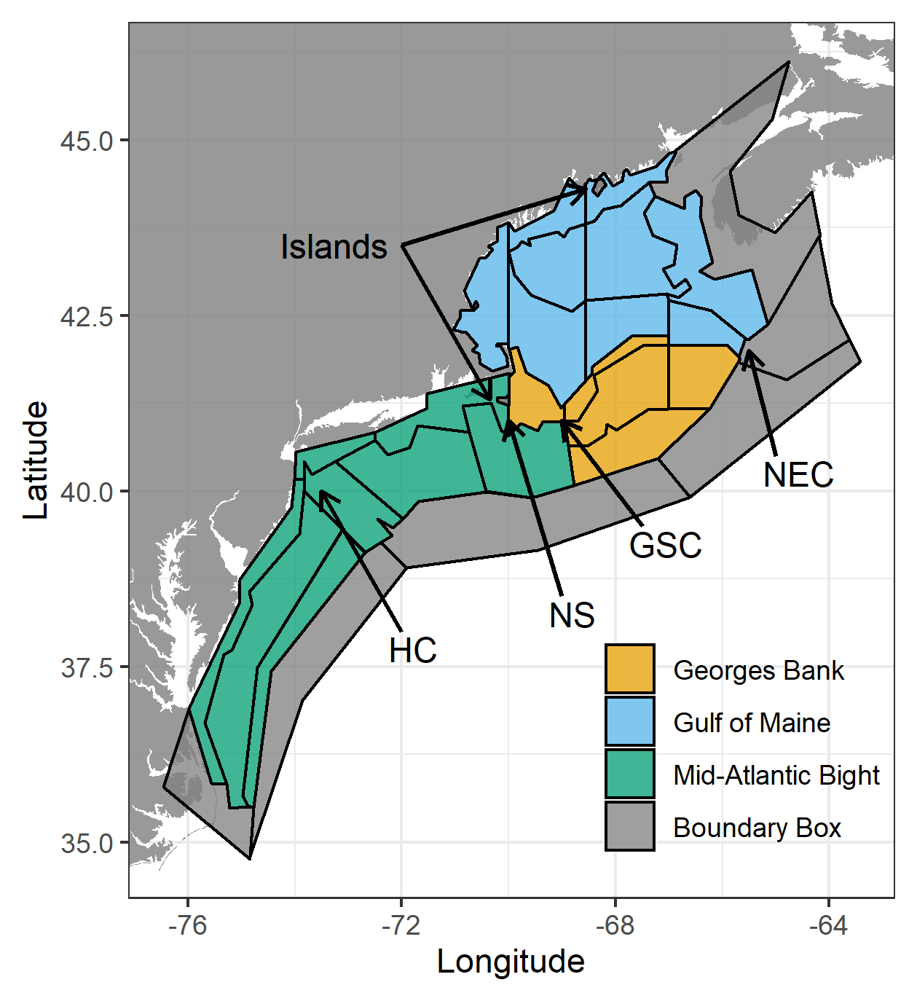

*Figure 1:**A map of the NEUSv2 box geometry and ecological production unit regions (colors). Arrows indicate the approximate location of the Northeast Channel (NEC), the Great South Channel (GSC), Nantucket shoals (NS), the Hudson canyon (HC), as well as the two island boxes. Boundary boxes do not need to conform to the coastline.*

NEUSv1’s functional groups were redefined in NEUSv2 to improve the model’s applicability to regional fisheries by splitting out all managed and environmentally important species into their own groups. NEUSv2 simulates 89 biological functional groups (Appendix C). These represent apex predators, marine mammals, pelagic and benthic fish, invertebrates, plankton, and detritus. Of these, 59 are age-structured vertebrates, 4 are age-structured invertebrates, 23 are biomass-pooled invertebrates, and 3 are detrital pools. Model output includes biomass (for all groups) and abundance (only vertebrates) at each boxes and layer. The model was run at a 24-hour time step and output every 5 days.

Generally, Atlantis has four forcing categories (Audzijonyte et al., 2017): state variables, fluxes, tracer variables, and time series inputs. State variables are uniform throughout a box-layer and include temperature, salinity, and vertical advection. Fluxes occur between the layers of two adjacent boxes, or faces, and include horizontal and vertical advection. Tracer variables are optional state variables that, when forced, overwrite the values calculated by NEUSv2, which is how phytoplankton forcing is implemented. Time series inputs drive additional processes (e.g. solar radiation and fisheries catch) and do not overwrite any existing variables.

NEUSv2 hindcast simulation runs from 1998 to 2018 with a 33-year spin up period. A repeated climatological year was generated using the mean day-of-year value from each forced variable’s source data. This climatological year was repeated annually from what would be 1964 until the annually-varying forcing data starts (1993 for physics and 1998 for phytoplankton). A climatology was used over repeating a single year from the forcing data to avoid outlier conditions in any particular year from creating an unreasonable equilibrium in biological groups. This spin up duration is comparable to that used in other Atlantis models (Bossier et al., 2018). The first post spin-up year is defined by the first year (1998) where all forced variables are using their original data source (i.e. not climatology). A spin up period in Atlantis allows biological processes to reach steady-state and for them to respond to the inter-annual variability in the forcing.

**2.2 Physical Forcing**

*2.2.1 Temperature and Salinity*

Within the Atlantis framework there are several ways to influence functional group processes based on environmental conditions (particularly temperature and pH). Presently in NEUSv2, temperature influences growth rates, clearance rates, and mortality of only invertebrates using a Q10 temperature coefficient. This functionality is planned to be incorporated and calibrated for HTLs in further updates. Sensitivity to salinity is not yet included for any functional groups.

GLORYS12V1 has been used in the northeast US continental shelf for a variety of applications, including regional temperature trends (Bastille et al., 2021), marine heat waves (Schlegel et al., 2021), and bottom temperature forecasting (Cai et al., 2021). Daily temperature, salinity, and horizontal advection were obtained from GLORYS12V1 global ocean reanalysis (CMEMS, 2018). This product has a gridded 8-km horizontal resolution, up to 50 fixed vertical depth bins, and extends from 1993 to 2018. A horizontal spatial mapping was used to assign the center point of each GLORYS12V1 grid cell to an Atlantis box. Within each GLORYS12V1 cell, depth bins were assigned a corresponding NEUSv2 depth layer. GLORYS12V1 depth bins extending deeper than corresponding NEUSv2 boxes were excluded.

Within each Atlantis box-layer combination, a weighted mean (by cell area) was taken for all GLORYS12V1 cells within a given box (i.e. horizontal aggregation). Then, a weighted mean of all GLORYS12V1 layers corresponding to each NEUSv2 layer was calculated (i.e. vertical aggregation), using the proportion that each GLORYS12V1 layer occupies a NEUSv2 layer as weights. The result was a single value per box-layer per day.

*2.2.2 Horizontal Advection*

In Atlantis, horizontal transport acts orthogonally to the vertical plane between two boxes (i.e. faces). The NEUSv2 faces are defined as rhumb lines between two box vertices. For all GLORYS12V1 cells intersecting a NEUSv2 face, a mean east-west ($u$) and north-south ($v$) component of horizontal advection was computed at each GLORYS12V1 depth bin. Then, as above, GLORYS12V1 depth bins were mapped to NEUSv2 layers, and a weighted mean was used to aggregate vertically, ensuring a single flux per face, per day. For each GLORYS12V1 cell, the magnitude of the horizontal velocity ($V_{z}$) for a layer (*z*) was defined as:

$$V_{z}= \sqrt{{u_{z}}^{2}+{v_{z}}^{2}}$$

With an associated flux angle ($θ$) defined as:

$$θ=\tan^{-1}\left(\frac{v}{u}\right)$$

The relative angle ($ψ)$ between the face and the velocity vector was calculated as:

$$ψ=\tan^{-1}\frac{sin \left(θ-ϕ\right) }{cos \left(θ-ϕ\right) }$$

Where $ϕ$ is the angle of the face. The cross-sectional area of the face ($A$) was calculated as

$$A=LΔ z$$

Where *L* is the length of the face and $Δ$ z is the depth of the NEUSv2 layer. Finally, the flux relative to each face ( $F)$ was calculated as

$$F= ±\left|cos \left(ψ+\frac{π}{2}\right) \right| A V_{z}$$

where the sign is dependent on the user-defined directionality of each Atlantis face.

*2.2.3 Vertical Advection*

Atlantis requires vertical advection as part of its physical forcing routines. Since daily vertical advection is not provided by GLORYS12V1 output, vertical advection was obtained from NASA’s ECCOV4 (ECCO Consortium, 2015). ECCOV4 has a similar horizontal resolution to NEUSv2 (1 $°$) and provides vertical advection on a monthly interval. In general, Atlantis boxes possess uniform vertical advection throughout, so only seasonality and larger-scale spatial patterns are relevant. All NEUSv2 boxes were mapped to ECCOV4 cells using spatial overlap or if ECCOV4 cell center points lay within 25-km of a box edge. The same vertical assignment and aggregation methods used for GLORYS12V1 state variables were used. For each box-layer, a daily interpolation of vertical advection was generated from monthly values using a kernel regression smoother, a normal distribution kernel, and a bandwidth of 15 days. Horizontal and vertical advection arrays were then run through a separate Atlantis program, Hydroconstruct. This program performs mass-balance and hyperdiffusion corrections on horizontal advection. It also translates box-level vertical velocities into actual box-layer exchanges and reconciles horizontal and vertical flows (Audzijonyte et al., 2017).

**2.4 Biological Forcing**

Generally, Atlantis possesses a primary producer sub-model that utilizes biological parameterization, physical forcing, trophic interactions, and biogeochemical processes to simulate phytoplankton growth and mortality. When using this sub-model, primary producer biomass is heavily influenced by parameter choice and requires extensive calibration. In reality, phytoplankton dynamics reflect small-scale processes which Atlantis cannot resolve with large boxes and global parameters. Given that the primary scope of NEUSv2 is simulating higher trophic levels on regional-scales, upscaling a higher resolution model to replicate large-scale patterns is sufficient. Primary producer biomass establishes a baseline level of primary production, provides bottom-up controls on higher trophic levels, and drives seasonal patterns in zooplankton. These effects should create stability for the simulated food web, ensure a correct scale of system energy input, and allow for a unidirectional (bottom-up) calibration strategy.

NEUSv2 phytoplankton size-classes, derived from ocean color remote sensing, were mapped to NEUSv2’s phytoplankton functional groups (diatoms, dinoflagellates, and picoplankton). Daily ocean color data (1998-2018) were obtained from the European Space Agency’s Ocean Color Climate Change Initiative (OC-CCI) version 4.2 (Sathyendranath et al., 2020), which provides global estimates of chlorophyll-*a* concentration at a 4-km2 horizontal resolution (Sathyendranath et al., 2019). Additional daily sea surface temperature (SST) data needed to estimate the phytoplankton size class include the 4-km nighttime NOAA Advanced Very High Resolution Radiometer (AVHRR) Pathfinder (“AVHRR Pathfinder Version 5.3, 2018; Casey et al., 2010) and the Group for High Resolution Sea Surface Temperature (GHRSST) Multiscale Ultrahigh Resolution (MUR, version 4.1) level 4 data (Chin et al., 2017; JPL MUR MEaSUREs, 2015). The AVHRR Pathfinder data are used as the SST source until 2002 and MUR in subsequent years. Comparisons to *in situ* measurements show a relatively low bias in the size class estimates with a bias of 0.04 and 0.08 mg Chl m-3 for micro- and combined pico- and nano-phytoplankton, respectively (Turner et al., 2021).

NEUSv2 uses the regionally tuned abundance-based phytoplankton size class model to estimate the amount of chlorophyll-a (Chl-*a*) associated with the micro- (>20 μm), nano- (2-20 μm) , and picoplankton (<2 μm) size classes (Turner et al., 2021). An 8-day moving average was used to reduce data gaps caused by cloud cover, after which each box had only 7 to 14 days of missing data per year on average. Then a cubic spline function was used to temporally interpolate time series within each box. At each time step the median of all pixels within each NEUSv2 box was used for each phytoplankton variable. Since NEUSv2 boxes are meant to represent typical processes within broad regions, the median was chosen specifically to avoid the overrepresentation of dynamics of small portions of a box (i.e. preventing high local primary production from extending across the entire region).

The phytoplankton size class data are a near-surface two-dimensional product that provides Chl-*a* in each cell aggregated over the euphotic zone, whereas NEUSv2 can simulate phytoplankton in each of the vertical layers. The euphotic depth derived from the Morel and Berthon (1989) model showed that the median daily euphotic depth across all NEUSv2 boxes was 41.2 m. Thus all forced phytoplankton biomass was assigned to the fixed-depth surface NEUSv2 layer (0-50m).

It was necessary to transform the phytoplankton size class estimates into NEUSv2’s predetermined phytoplankton functional groups. The Turner et al. (2021) microplankton was assumed to be a combination of diatoms and dinoflagellates. To differentiate these functional groups, we estimated the diatom fraction from the global Hirata et al. (2011) phytoplankton functional type model derived from the same OC-CCI data as the Turner et al. (2021) data. The remainder of the large phytoplankton size class were assigned to dinoflagellates. This proportion was calculated as a day-of-year median from 1998 to 2019 and applied across all years. Diatom proportions differed by box as well as seasonally with a mean of 0.89 ± 0.07 SD. The sum of the Turner et al. (2021) nano- and picoplankton were assigned to the NEUSv2 picoplankton functional group. This “picoplankton” group in NEUSv2 is actually a “small” phytoplankton group distinguished primarily by their smaller size, slower sinking rate, and higher consumption by microzooplankton. The NEUSv2 chlorophyll to nitrogen conversion factor of 7 was used to convert the chlorophyll units from mg m-3 of Chl-*a* to the required units of mg N m-3 and was derived from a Chl-*a*:Carbon range of 27-67 (Riemann et al., 1989) with a redfield ratio C:N of 7.

3. Analysis

The following analyses are aligned with the three main objectives of the paper. First, we assess NEUSv2’s performance relative to our calibration criteria. Second, we quantify the bias in hydrographic and satellite forcing datasets after upscaling to the NEUSv2 box structure. Lastly, we analyze the spatial patterns of zooplankton, herbivorous benthos, and planktivorous fish groups to ensure these groups are responding realistically to forced primary producers. Additional work regarding further calibration of higher trophic levels and determining the sensitivity of NEUSv2 to other forcing models and parameter choice, is ongoing and outside the scope of this study.

**3.1 Calibration Criteria**

We used two minimum performance standards to evaluate biomass time series of functional groups based on guidelines suggested by Kaplan and Marshall (2016). The first criteria, persistence, was that no functional groups go extinct during the hindcast by maintaining a domain-wide biomass above 10% of the starting biomass. This criterion ensures that simulated diets are roughly balanced as well as that recruitment and growth parameterizations can sustain each population. The second criterion, stability, was that no functional group’s domain-wide biomass time series possessed a relative rate of change of 5% per year or greater over the last 20 years of the simulation, ensuring a baseline level of time series stability and that no functional groups are exhibiting extreme population growth.

Both calibration criteria thresholds were based on analyses of NOAA’s StockSmart assessment database (NOAA Fisheries, 2022). Biomass time series were obtained for all NEUSv2 species available in NOAA’s StockSMART stock assessment database (NOAA Fisheries, 2022). The minimum of each species’ biomass (relativized to the earliest year) was used as the threshold for persistence, where the median across all species was 14% of initial biomass. StockSmart species’ relativized biomass from 1998 to 2018, after a linear regression showed a median slope across species of 4% per year.

**3.2 Upscaling Assessment**

For the GLORYS12V1 temperature and salinity as well as the satellite phytoplankton biomass, a mean daily bias was calculated on the original high resolution grid to determine whether the values provided to NEUSv2 were representative given the spatial distribution of variables within each box. With each NEUSv2 box, layer, and day, the box-wide NEUSv2 value was subtracted from each forcing product cell’s value. The mean of all cell-level biases were calculated to obtain a daily mean bias for each NEUSv2 box-layer. For each box-level variable a two-way ANOVA was performed (bias ~ box ⨉ season) to determine whether significant differences in mean bias were present.

Horizontal advection acts across all box faces simultaneously and represents the net flux of all transport across the faces adjoining any two boxes. As primary producer processes captured by the new forcing, in Atlantis, circulation still determines the flow of nutrients. In order to assess broad circulation patterns, the net transport was calculated across all faces adjoining each pair of boxes. This was then converted to a mean daily flow speed ($\underline{V}$) for each layer of each box-pair whereby $\underline{V}=T/ (L Z)$ where *T* is the net transport between boxes, *L* is the total length of all faces that adjoin the boxes, and *Z* is the depth of that given layer. Then semi-quantitative evaluations of specific circulation features were used to determine the translation of the upscaled circulation. A daily mean bias in flow speed was also calculated on each NEUSv2 face, using similar methods to that described for box-wide variables. Instead, only GLORYS12V1 cells that intersect each NEUSv2 face were used in calculations.

**3.3 Spatiotemporal Patterns in Output**

Box-level NEUSv2 output variables were aggregated to the Northeast Fishery Science Center’s ecological production units (EPUs; Figure 1; Bastille et al., 2021): the Mid-Atlantic Bight (MAB), Georges Bank (GB), and the Gulf of Maine (GOM). These regional assignments allowed for comparisons to regional reports, and a more intuitive interpretation of regional oceanographic and ecological patterns. All further references to biomass outputs, will be presented as the aggregations by EPU. In order to allow biomass comparisons between EPUS of different size, pelagic group biomass was standardized by box volume and epibenthic biomass was standardized by box area. The 5-day output was also aggregated as seasonal means and defined as: winter (January-March), spring (April-June), summer (July-September), and fall (October-December).

The analysis of the NEUSv2’s functional group biomass output in this study is constrained to only those functional groups that relate to phytoplankton and grazers (zooplankton, benthos, and planktivores). A description of the other function groups is outside the scope of this study. In addition to the three phytoplankton groups, the three zooplankton groups (macro-zooplankton, mesozooplankton, and microzooplankton), benthos, and planktivores are described. The benthos and planktivore categories comprise of 9 and 7 true NEUSv2 functional groups, respectively (Table 1), and are combined for illustrative purposes only.

Time series decomposition was used to isolate seasonality in functional group biomass output. This method allows for a clearer understanding of when seasonal events occur and the relative timing of groups’ cycles. Time series decomposition was performed with the Multiple Seasonal-Trend decomposition using Loess (MSTL) algorithm on the monthly and EPU-level biomass of each functional group output using the *mstl* function from the R package “forecast” (v8.13; Hyndman and Khandakar, 2008). This function uses loess smoothing to extract repeating seasonal cycles from the time series. To compare seasonal cycles of groups with different intra-annual variances, a standardized seasonality index was constructed as the monthly mean seasonality divided by the time series’ standard deviation.

The Coastal and Ocean Plankton Ecology, Production, and Observation Database (COPEPOD; Moriarty and O’Brien, 2013) provides total carbon mass (mg C m-3) as a gridded monthly product aggregated over several years of data and was used as a reference point for evaluating NEUSv2 zooplankton. The COPEPOD grid was mapped to the NEUSv2 EPUs and a seasonal mean concentration was calculated. The mean seasonal NEUSv2 zooplankton concentration was calculated from the sum of all three NEUSv2 zooplankton size classes and converted to carbon using Atlantis’ Redfield ratio. Then the ratio of COPEPOD to NEUSv2 biomass concentration was calculated. As a multi-year aggregated product and the unknown size-distribution of zooplankton in COPEPOD, NEUSv2 values within an order of magnitude were considered similar.

**3.4 Trophic Interactions**

To determine how much primary producer biomass transferred to pelagic and benthic food webs, the consumed biomass (*C*) of each phytoplankton group (*p*) by each grazer (*g*) was calculated:

$$C_{g,p}= P_{g,p}E_{g}$$

where *Eg* is the total consumed biomass of each predator and *Pg,p* is the mean proportion of each predator’s diet that constitutes phytoplankton group *p*. Atlantis’ biological forcing only operates on functional group biomass, so phytoplankton biomass was chosen over net primary production as the focal metric. Then, the proportion of each phytoplankton group biomass consumed (*Pp*)was calculated

$$P_{p}= \frac{\sum_{g}{C_{g,p}}}{B_{p}}$$

where *Bp* is the total biomass of phytoplankton group *p*. The relative contribution of each grazer to the consumption of phytoplankton *p* (*Gg,p*)was calculated:

$$G_{g,p}= \frac{C_{g,p}}{\sum_{g}{C_{g,p}}}$$

*C*, *P*, and *G* were calculated on each 5-day time step.

The contribution of each settling phytoplankton group towards total sediment deposition is not tracked within Atlantis outputs. In order to estimate it, the deposition flux for each functional group attributable to passive sinking alone was calculated. The biomass flux of sinking phytoplankton (*Fp*) used in Atlantis from one box layer to the one below is calculated as $F_{p}=C_{p}W_{p}A$ where *Wp* is the sinking velocity of phytoplankton, and *A* is the horizontal area of the box. Thus the proportion of each phytoplankton sinking from any given pelagic layer (*Dbox,p*) can be calculated as $D_{box,p}=\frac{F_{p}}{C_{p}V}=W_{p}/ Z_{box}$, where *V* is the box volume and *Zbox* is the depth of the pelagic layer.

4. Results

**4.1 Upscaling Assessment**

*4.1.1 Physical Forcing*

NEUSv2 was able to reproduce many of the region’s broad circulation characteristics observed in GLORYS12V1 (Figure 2). Given that NEUSv2 uses only 151 faces to define circulation, it was not expected that NEUSv2 could reproduce circulation features on scales smaller than its boxes. However, verifying broad circulation patterns ensures that nutrients, detrital pools, and passively transported functional groups behave realistically.

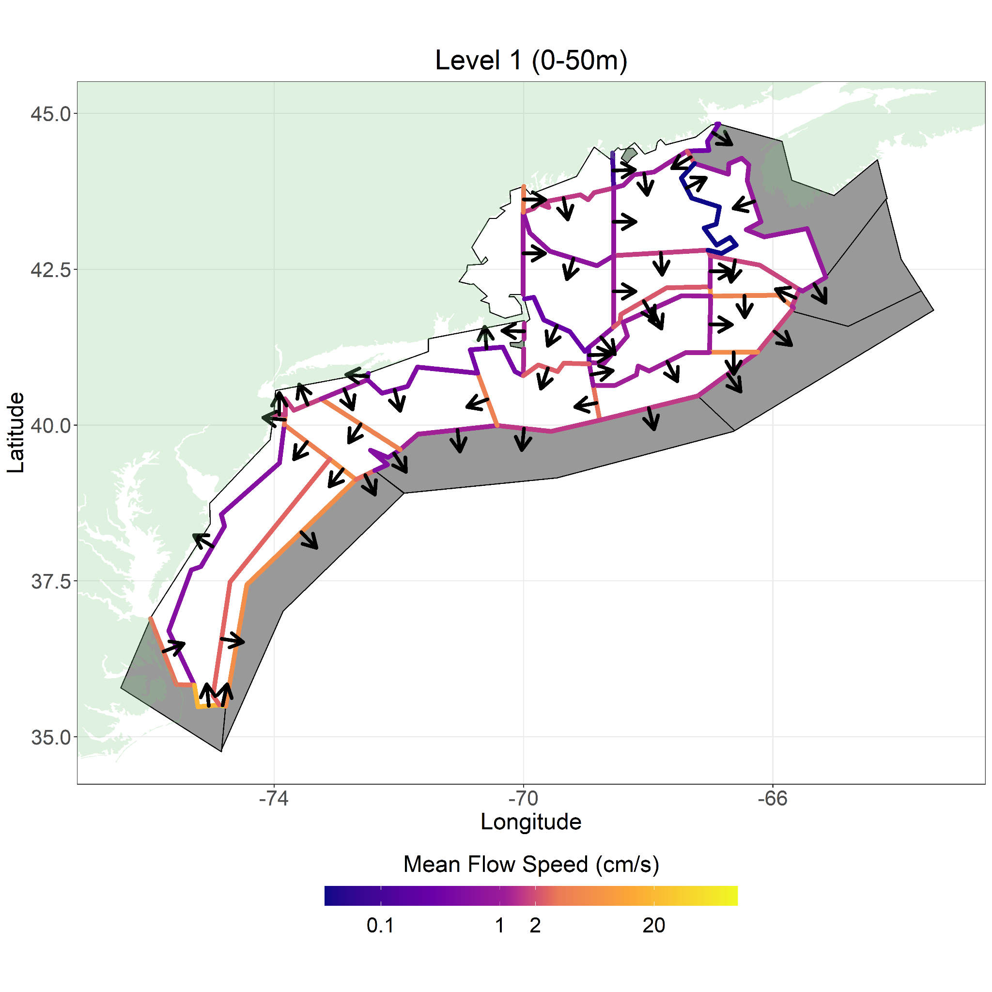

*Figure 2: The mean flow speed and direction is shown for each NEUSv2 face based on the day-of-year climatological forcing. Line colors show the flow speed (cm s-1) and arrows show the direction of the flow across each face. Boxes shaded in gray are boundary boxes.*

In the mid-Atlantic Bight (MAB), cross-shelf faces correctly show a southerly surface flow of 2 to 6 cm s-1 which is consistent with observations (Lentz, 2008). Surface horizontal fluxes were most variable in spring (1.58 cm s-1 SD) and least in summer (1.44 cm s-1 SD). An unusually large northward flow enters along the short faces in the southern MAB. Although the Gulf Stream is typically more offshore (Frankignoul et al., 2001), a strong northward flow component where the Gulf Stream separates from the coastline in those few GLORYS caused a large flux.

Typically, surface circulation is cyclonic in the GOM and anticyclonic over GB (Pettigrew et al., 2005). While NEUSv2 was able to capture this pattern in GB, the simulated GOM circulation showed a flow reversal in the coastal boxes. GOM surface and slope water typically enters through the Northeast Channel (NEC) and exits in the Great South Channel (Figure 1) or around the northeastern flank of GB (Brooks, 1985). NEUSv2 correctly captured the influx of surface water northwest into the GOM through the Labrador shelf and the Northeast Channel, as well as the surface and mid-depth southwest flow through the South Channel. In the NEC, a deep water counter-current is present (Zhang et al., 2019), and while it is not possible to reproduce this given the resolution of NEUSv2, it might explain the southeast flow in the deepest layer of the NEC box. The coastal cyclonic flow in the GOM was not resolved in NEUSv2 given its sparse face density. The influence of circulation on phytoplankton is already captured in the satellite data, thus possible discrepancies in NEUSv2’s circulation should not strongly influence lower trophic level dynamics.

The box geometry of NEUSv2 allows for a better approximation of the GLORYS12V1 temperature (Figure 3) and salinity (Figure 4) patterns than it does for circulation, as boxes are based largely on bathymetric features. The expectation was that NEUSv2’s box geometry and the upscaling process did not inhibit its ability to resolve seasonal patterns and spatial patterns at scales at or larger than its boxes. NEUSv2’s surface layer (0-50m) resolved the cross-shelf temperature gradient in the MAB spring and fall in GLORYS12V1 as well as the latitudinal temperature gradient in all seasons (Figure 3). Patterns of temperature bias within NEUSv2 boxes (Figure 5) show that the strong latitudinal gradients in the MAB and shelf-break boxes resulted in divergent patterns of bias where bias was higher in the south and lower in the north of each box. In contrast central GOM and northern GB boxes had a narrower temperature distribution resulting in less divergent patterns of bias. Box-level temperature bias in the NEUSv2 surface layer (0-50m) is generally negative (-0.06 to 6x10-4 oC) due to skewed GLORYS12V1 temperature distributions. GOM boxes had similar temperature bias, but significant differences between boxes were present overall (ANOVA: p << 0.001). The southern MAB boxes at all depth levels had more negative temperature biases.

NEUSv2 correctly reproduces the lower spatial variation in salinity from GLORYS12V1 (Figures 4), as well as the decreasing salinity gradient from offshore to inshore. Salinity bias magnitudes were small (-0.02 to 0.005) and differed between boxes (Figure 5; ANOVA: p << 0.001). As with temperature, salinity bias was closer to zero in the GOM and GB boxes, with significantly more negative bias in the southern MAB at all depth levels. The salinity difference between the GOM and the MAB is more pronounced as depth increases and is seen in both models (Figure 4). Patterns of within-box bias are mainly driven by cross-shelf gradients, as opposed to latitudinal gradients with temperature. Overall, temperature and salinity bias, while more extreme on the scale of GLORYS12V1, is sufficiently low for the purpose of reproducing the large-scale processes necessary for NEUSv2.

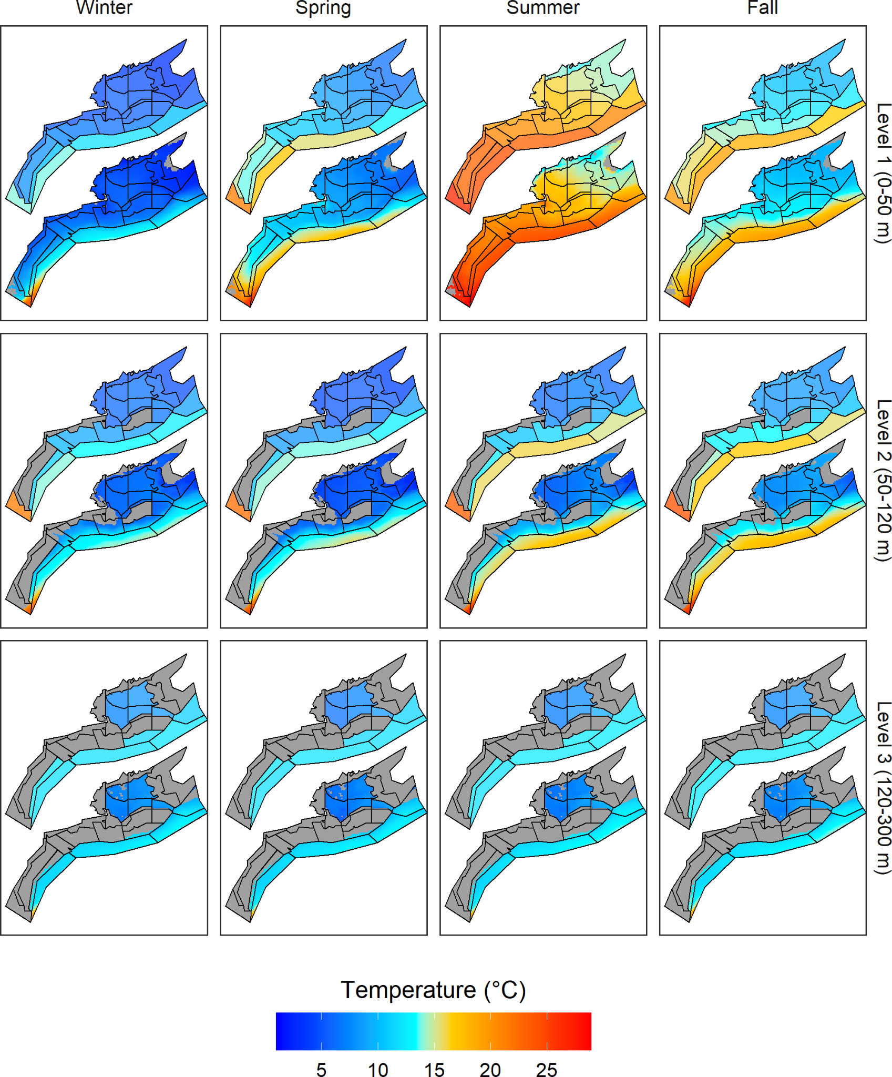

*Figure 3: Each panel shows NEUSv2 (upper map) and GLORYS12V1 (lower map) temperature as seasonal means (columns) for each NEUSv2 depth layer (rows). NEUSv2 temperature is shown as box means, and GLORYS12V1 is shown on its original 4km resolution, with NEUSv2 boxes overlaid for illustration.*

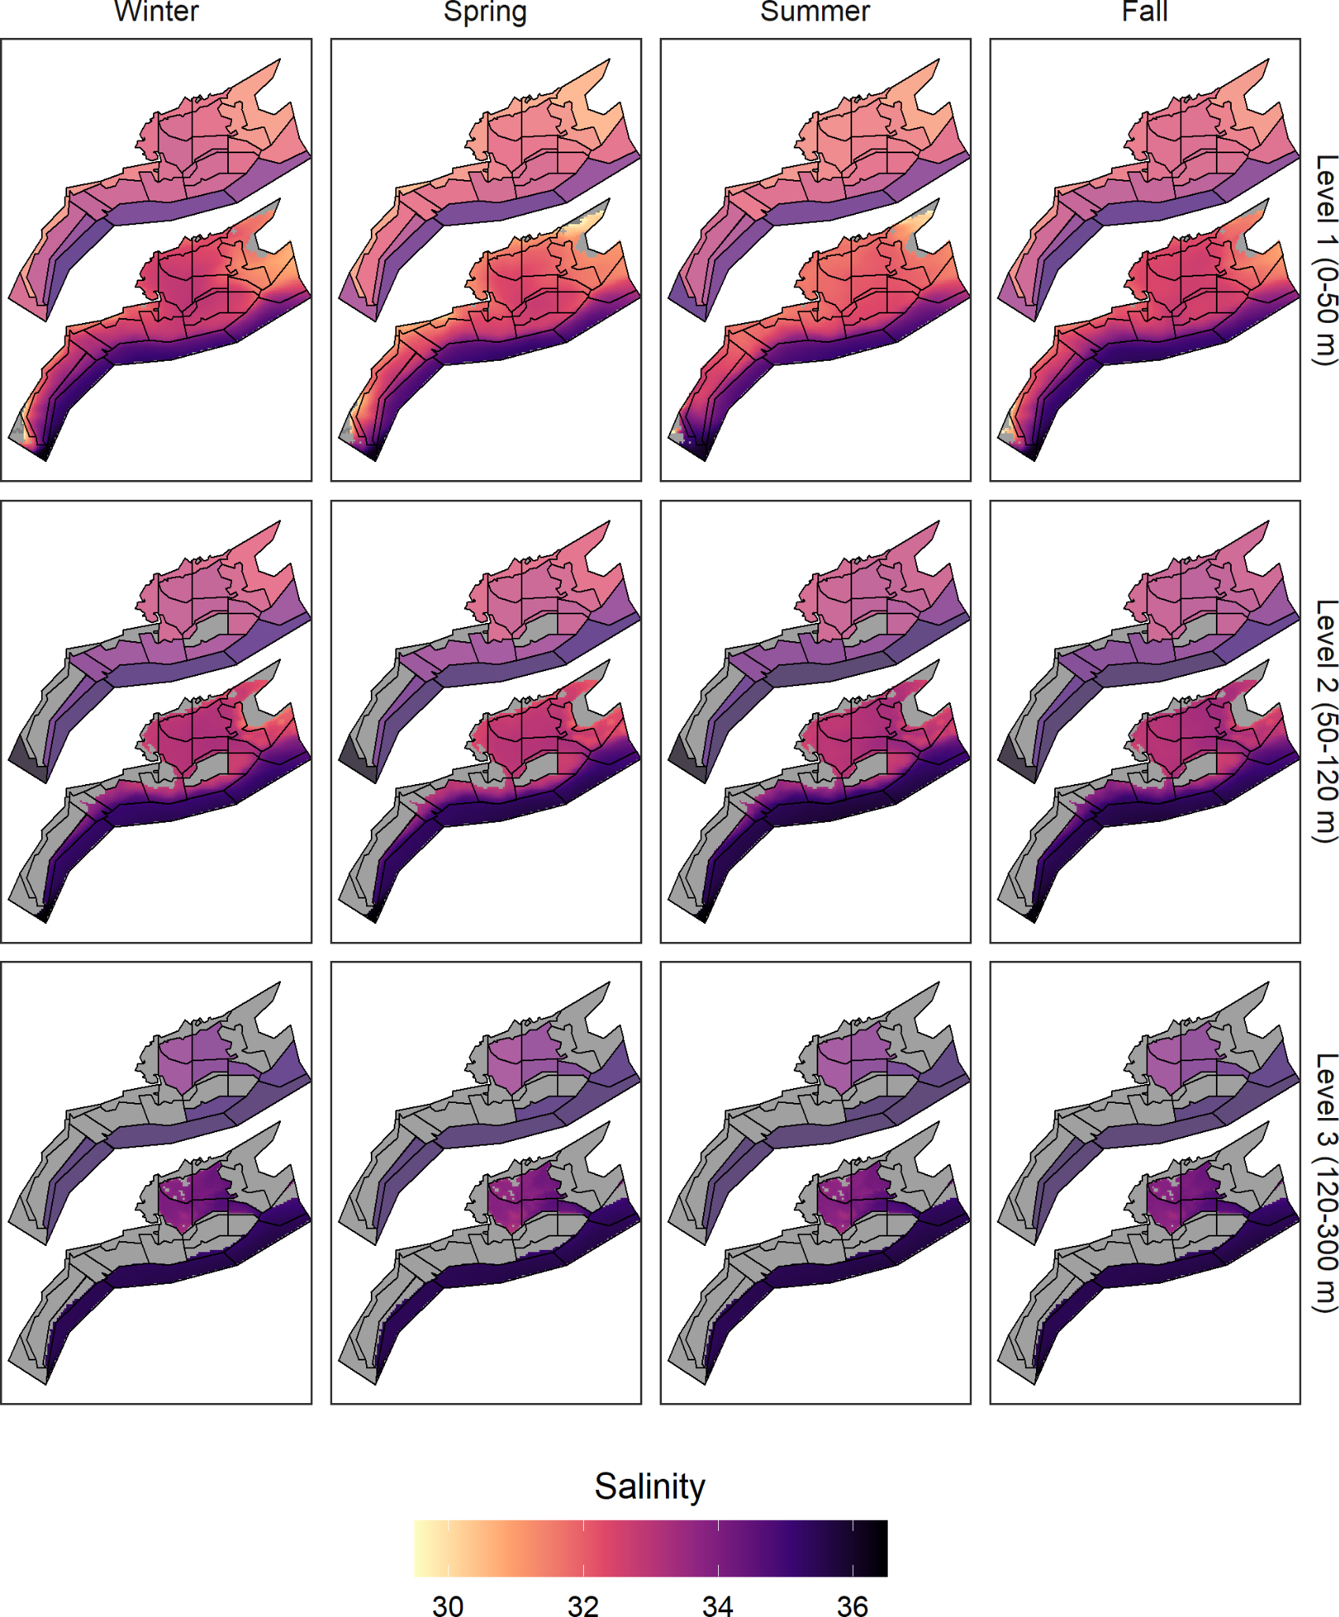

*Figure 4: Each panel shows NEUSv2 (upper map) and GLORYS12V1 (lower map) salinity as seasonal means (columns) for each NEUSv2 depth layer (rows). NEUSv2 salinity is shown as box means, and GLORYS12V1 is shown on its original 4km resolution, with NEUSv2 boxes overlaid for illustration.*

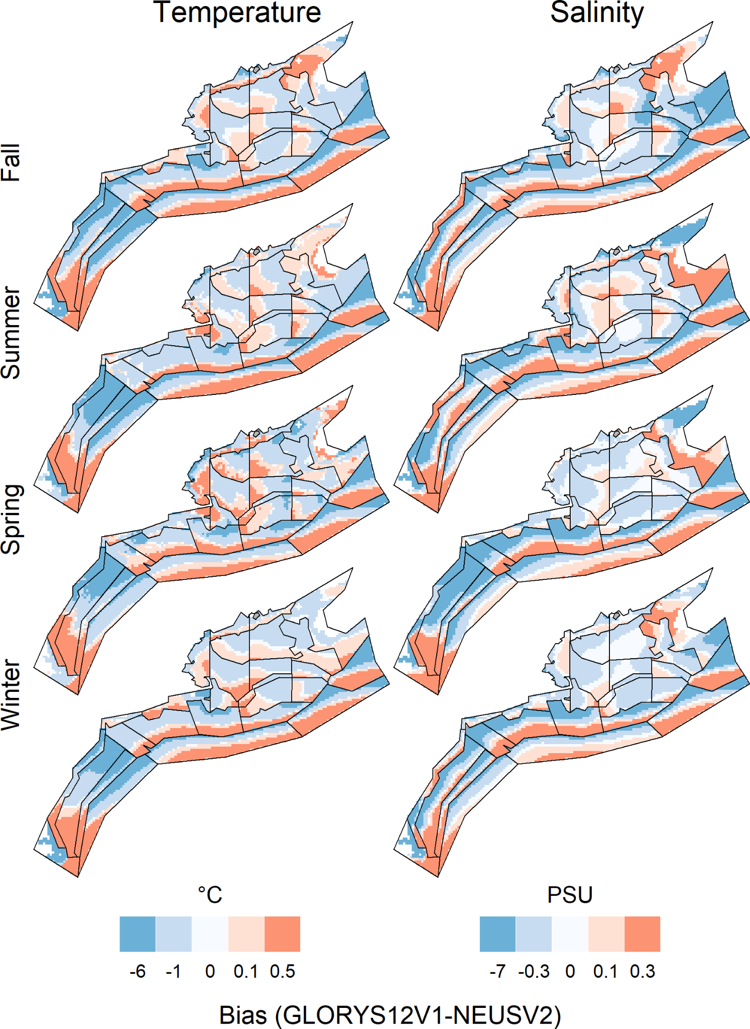

*Figure 5: Mean temperature (left column) and salinity (right column) bias (GLORYS12V1 - NEUSv2) using all GLORYS12V1 data from 1993 to 2018. Bias is calculated on the GLORYS12V1 4 km2 grid with respect to the NEUSv2 box value that represents each grid cell. Separate bias calculations are made for each season (rows). All panels show depth-averaged values corresponding to the NEUSv2 surface layer (0 to 50 m).*

*4.1.2 Biological Forcing*

NEUSv2 boxes resolve much of the spatial and seasonal variation in surface Chl-*a*in the satellite data (Figure 6). Furthermore, NEUSv2 correctly reproduces elevated Chl-*a* within nearshore boxes and the central GB and decreased Chl-*a* offshore and in the central GOM. The elevated Chl-*a* observed over Nantucket Shoals is dampened in NEUSv2 by the upscaling processes (Figure 6). Nantucket Shoals is a feature on a similar spatial scale to NEUSv2 boxes, yet it is divided between multiple boxes. Generally, upscaling resulted in a damping of the intensity of the elevated Chl-*a* .

All NEUSv2 phytoplankton size classes show similar overall patterns to total Chl-*a* with higher concentrations nearshore and over GB as in the satellite data. Analyses of bias in size-class Chl-*a* concentration show the presence of significant box differences (ANOVA: p << 0.001). Patterns in phytoplankton size-class bias (Figure 7) showed similar levels of bias in offshore or deeper water boxes. The spatial heterogeneity in concentration within nearshore boxes results in significant differences in bias. Overall the mean seasonal concentration of diatoms is about 9 times higher than dinoflagellates. The ratio of diatoms to picoplankton varies seasonally with a maximum of 7:5 in winter and a minimum of 7:10 in summer.

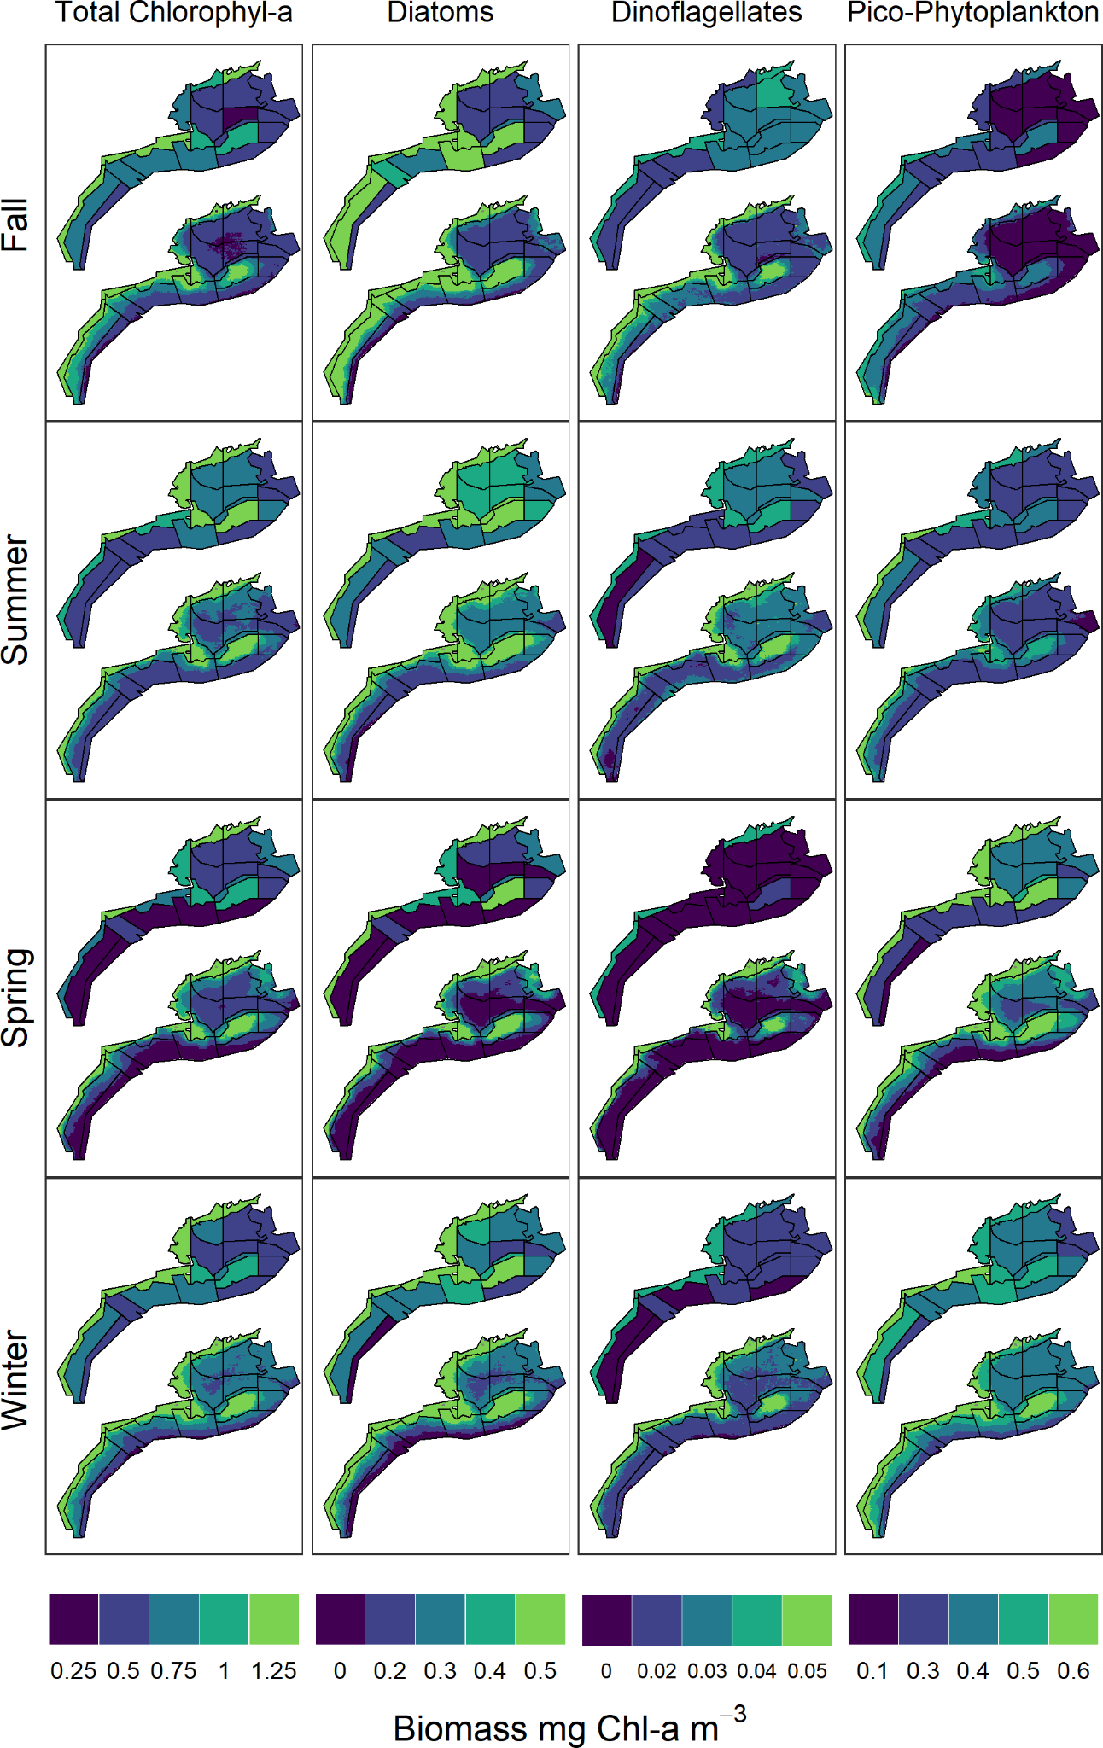

*Figure 6: Each panel shows NEUSv2 (upper map) and Turner algorithm (lower map) total chlorophyll-a (column 1) and phytoplankton size class chlorophyll-*a *(columns 2 - 4) as seasonal means (rows). NEUSv2 values are shown as box means, and GLORYS12V1 are shown on its original 4km resolution, with NEUSv2 boxes overlaid for illustration.*

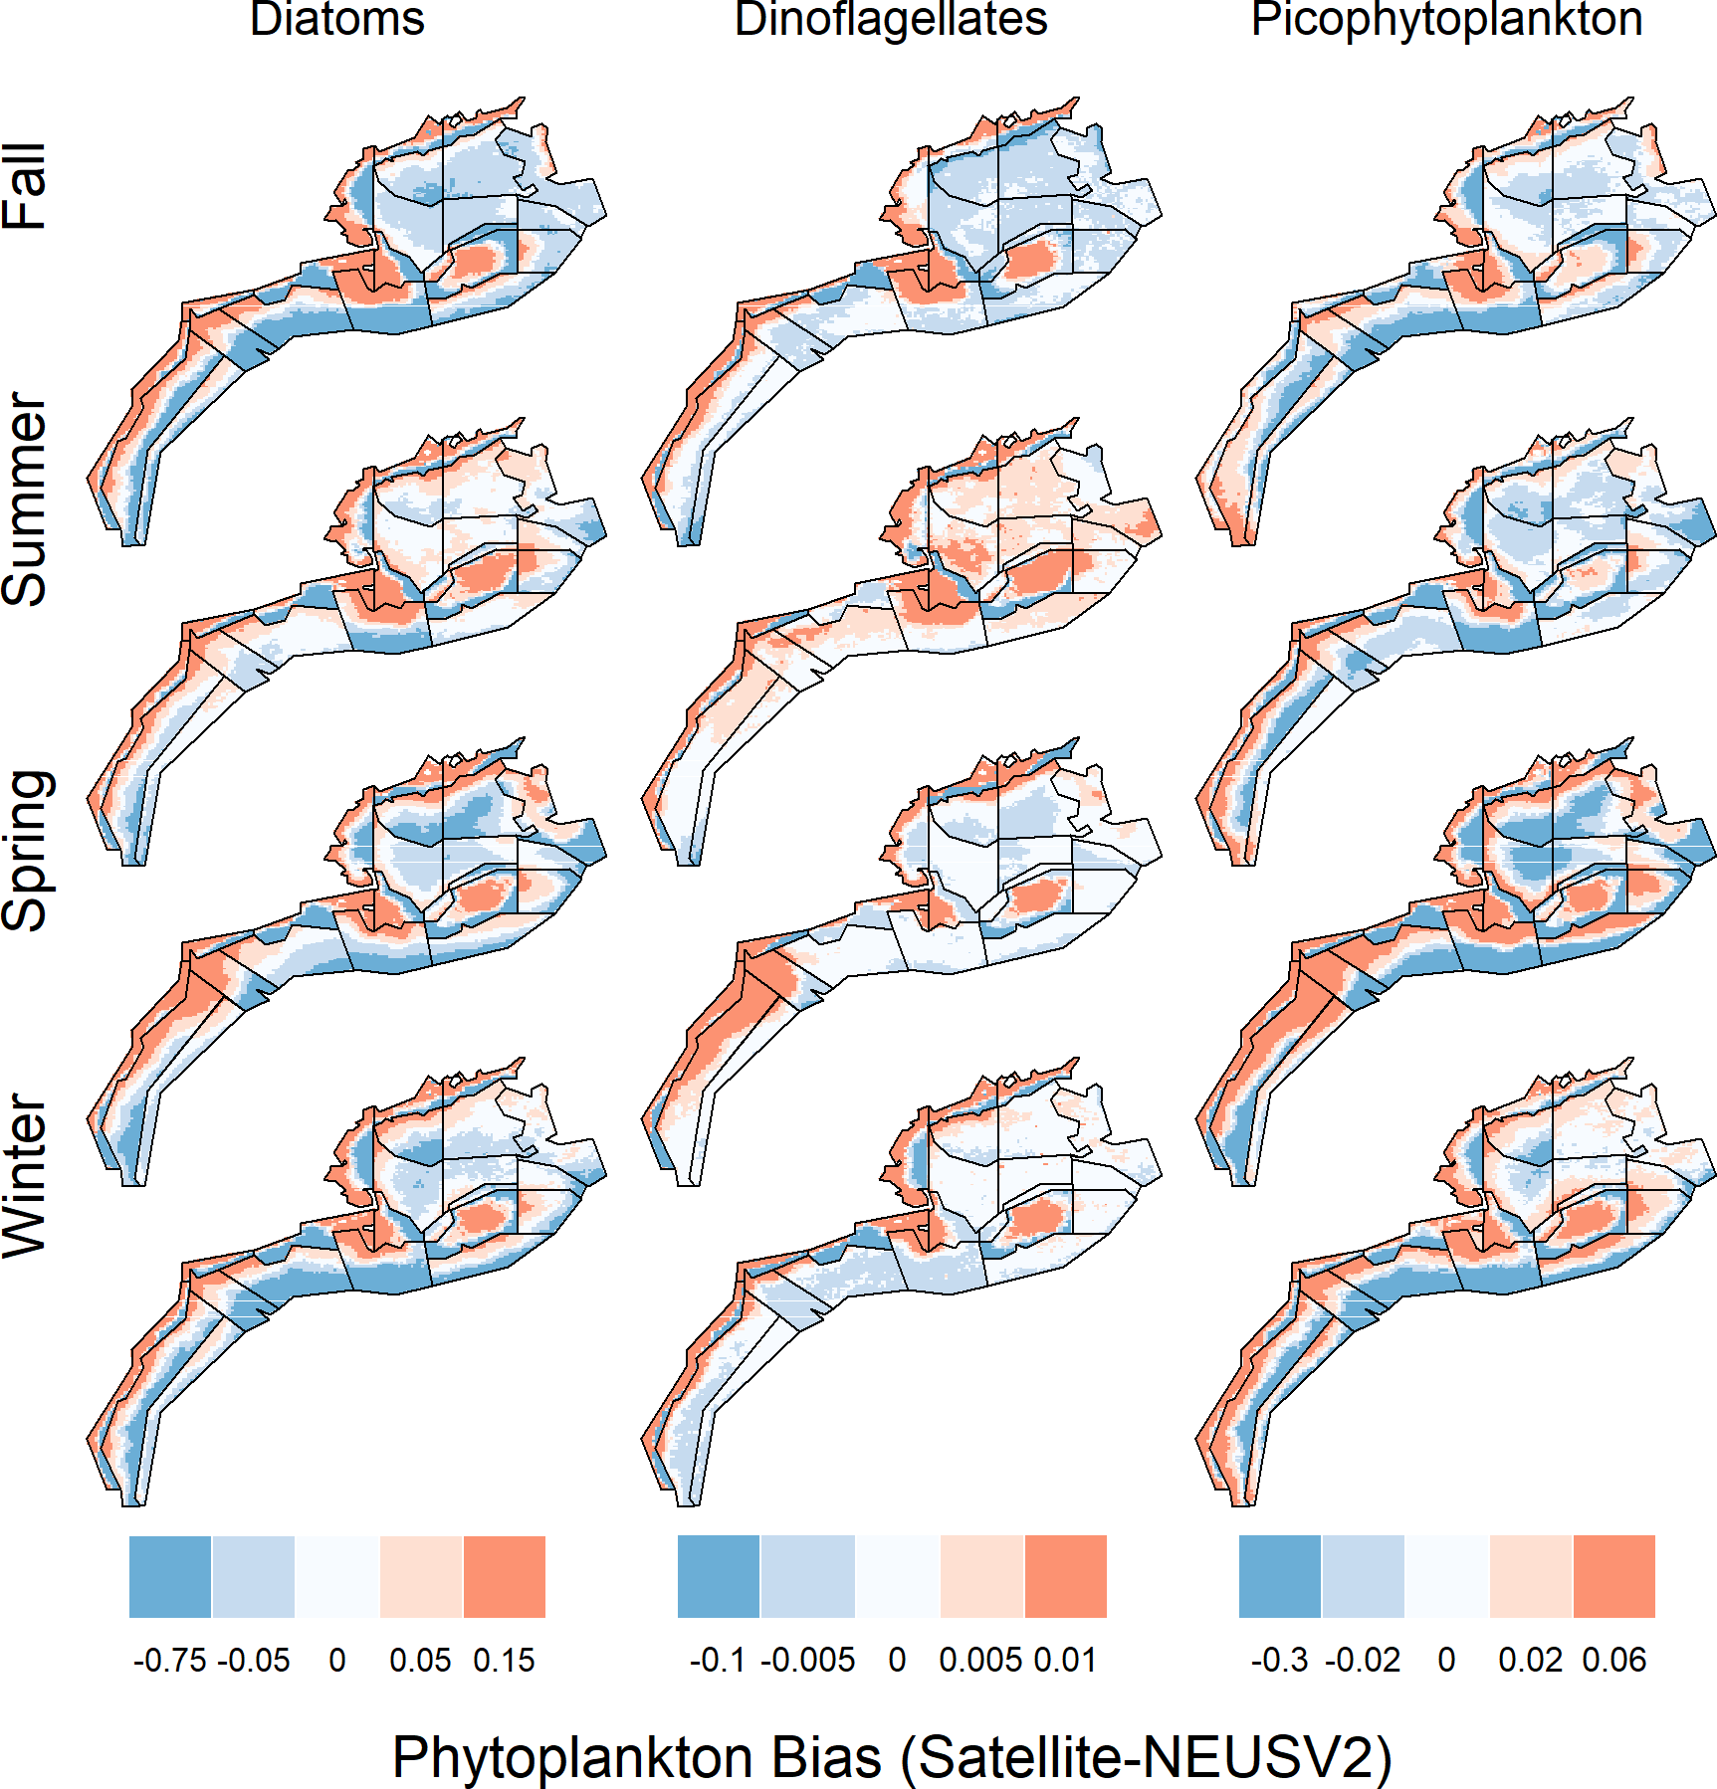

*Figure 7: Mean bias (Turner Algorithm - NEUSv2) in phytoplankton biomass for diatoms (column 1), dinoflagellates (column 2), and picoplankton (column 3). Bias is calculated on the OC-CCI 4 km2 grid with respect to the NEUSv2 box value that represents each grid cell. Separate bias calculations are made for each season (rows). All panels show depth-averaged values corresponding to the NEUSv2 surface layer (0 to 50 m).*

**4.2 Spatial and Temporal Patterns**

*4.2.1 Phytoplankton and Zooplankton*

The seasonality of NEUSv2 phytoplankton was not affected by the upscaling process. Diatoms were the dominant phytoplankton group in GB and the GOM, but were generally equal in biomass to picoplankton in the MAB (Figure 8; Table 1). Diatoms bloomed in spring in all regions and fall in the MAB. Dinoflagellate blooms occurred in spring and fall in all regions. Picoplankton blooms occurred in summer and fall in GB and the GOM, while blooms occurred in spring and fall in the MAB.

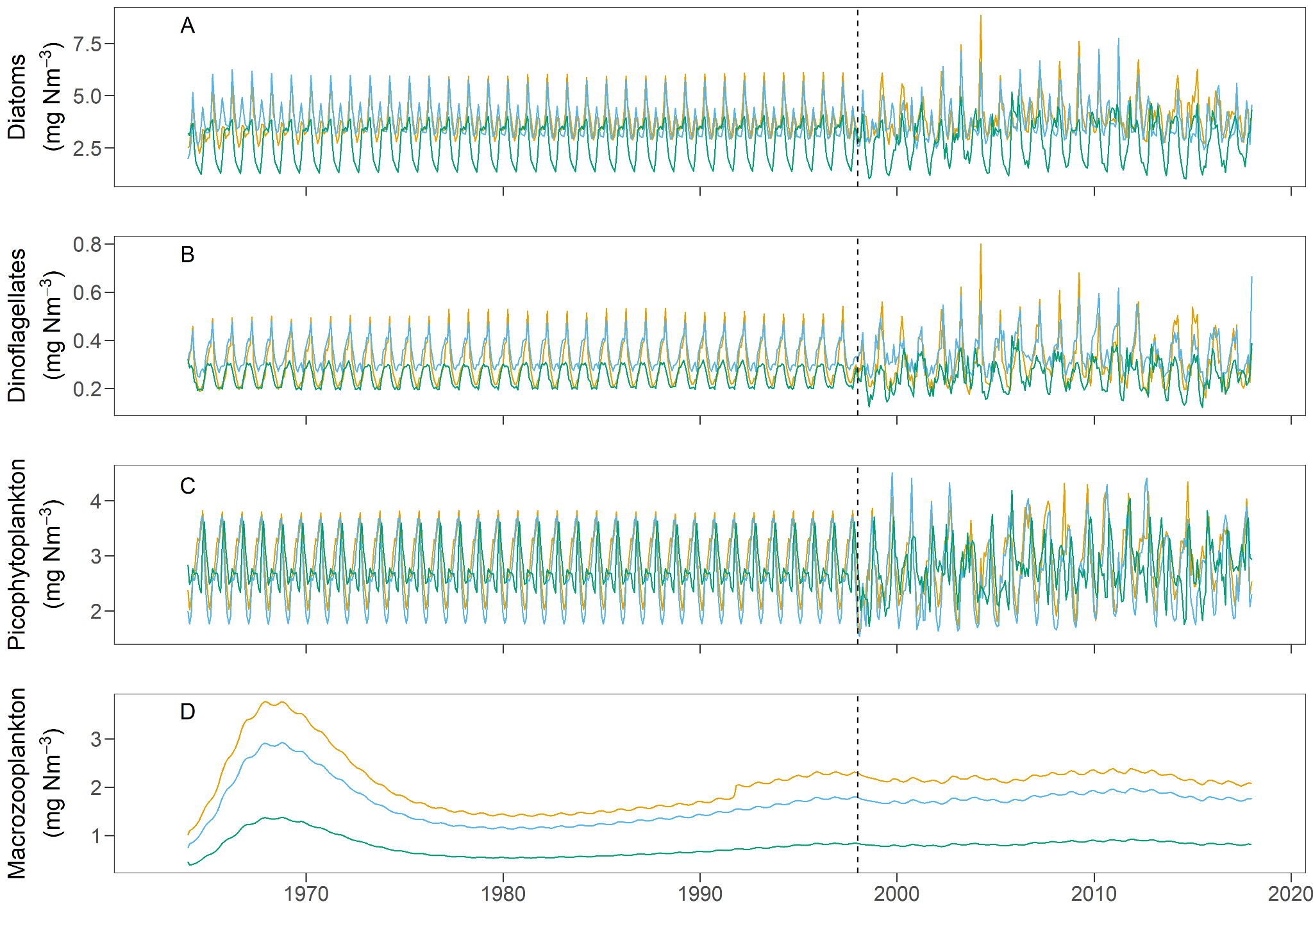

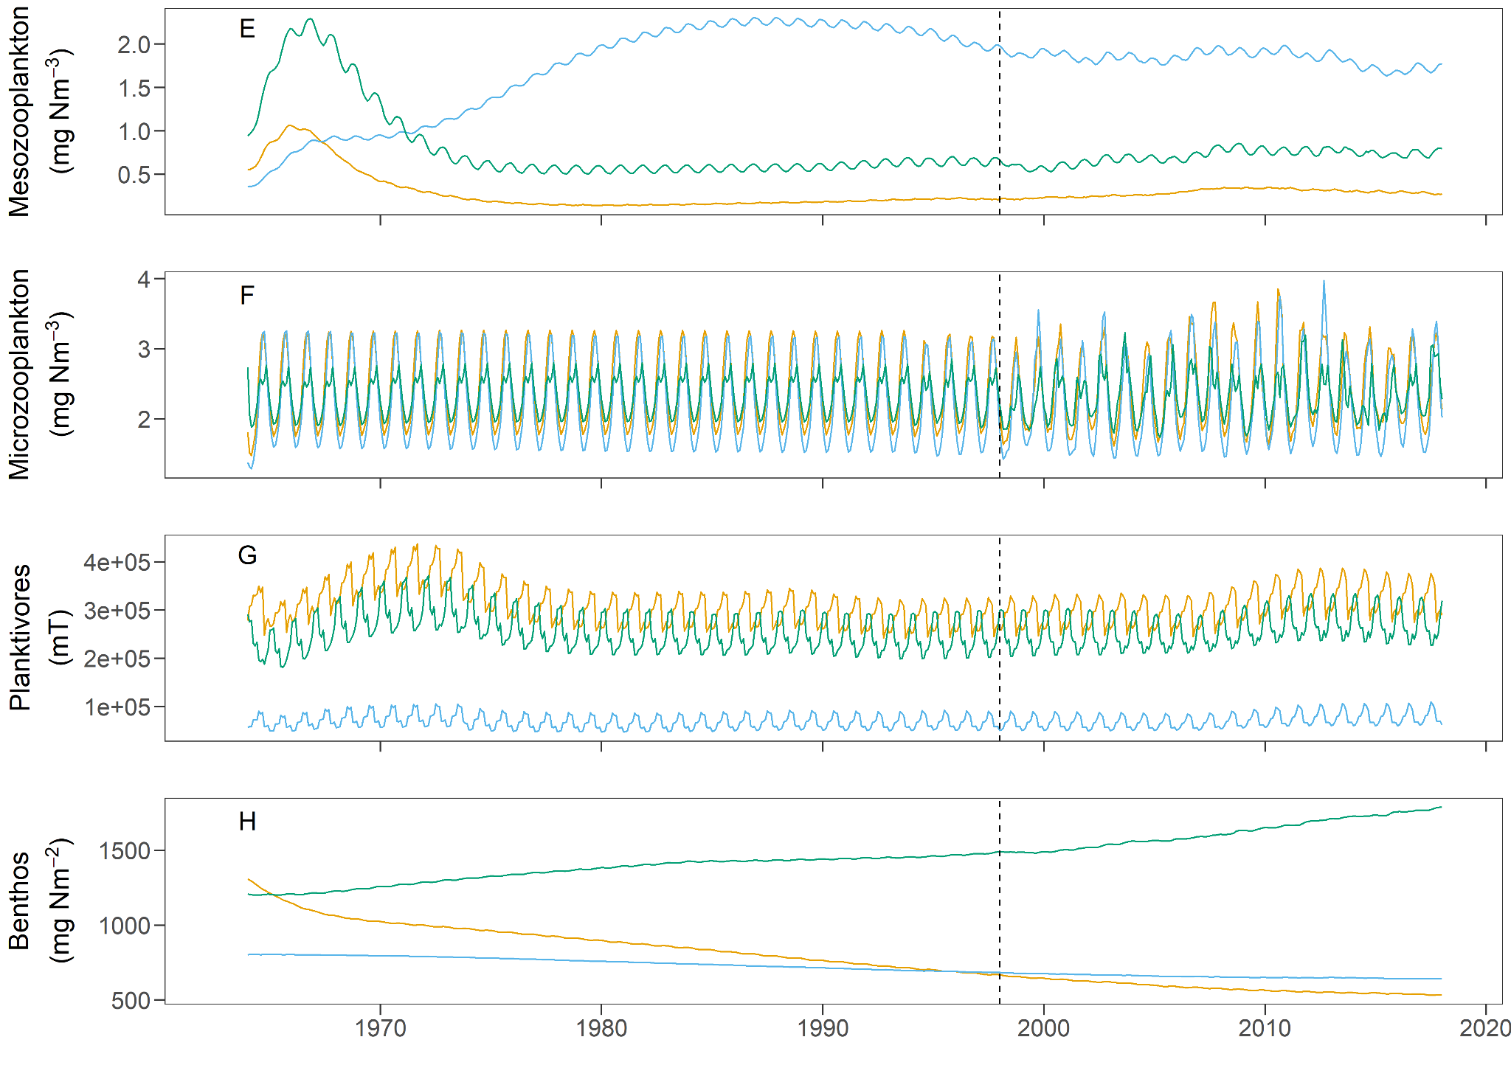

*Figure 8: Monthly standardized biomass for select NEUSv2 functional groups and for each ecological region (Georges Bank - orange, Gulf of Maine - blue, and Mid-Atlantic Bight - green). Panels A-F show biomass as a volume-standardized concentration (mgN m-3), panel G as a volume-standardized biomass (mT), and panel H as an area-standardized biomass density (mgN m-3). Vertical lines show the end of the defined spin-up period. Planktivores and benthos are aggregated guilds (Defined in Table 1).*

Zooplankton composition differed between the three regions, where micro-, meso-, and macrozooplankton were relatively prominent in GB, the MAB, and the GOM, respectively, but all zooplankton groups maintained robust fractions in all regions (Figure 8; Table 1). Microzooplankton were strongly coupled to picoplankton through diet interactions resulting in an indirect coupling of macro- and mesozooplankton to picoplankton through their diet interactions. Microzooplankton biomass peaks in the fall in all EPUs just after picoplankton blooms (Figure 9). Both meso- and macrozooplankton required 10 to 20 model years to reach a stable biomass, with mesozooplankton stabilized at a mean biomass between 1.9 and 3.1 starting biomass and macrozooplankton stabilized at 4 times starting biomass. While initial values are on the same order of magnitude as the COPEPOD dataset, zooplankton initial conditions are uncertain due to data limitations and may not necessarily represent the target biomass for contemporary conditions.

NEUSv2 generally overestimated the zooplankton biomass seen in the COPEPOD dataset. Winter concentrations were much higher (1.4 to 1.7 times), with more comparable ratios (1 to 1.9 times) in the other seasons. NEUSV2 zooplankton have a predefined vertical and horizontal distributions, so this discrepancy is not caused by an overwintering behavior but rather may be due to the poor sampling coverage the COPEPOD during those months (N = 1,121 in winter compared to N = 2,481 in spring). The ratio between COPEPOD and NEUSv2 zooplankton was not consistently dependent on EPU (Figure S1). The COPEPOD dataset likely underestimates microzooplankton due to larger mesh size selectivity and its sparse spatiotemporal resolution. We assess that NEUSv2 provides a reasonable approximation of zooplankton biomass, as it lies well within an order of magnitude of total zooplankton biomass available in COPEPOD.

The seasonal decomposition of biomass timeseries for each functional group showed a clear succession of zooplankton groups within a year (Figure 9). In all EPUs, a bloom of microzooplankton occurs after a rise in picoplankton, and mesozooplankton respond to either the microzooplankton blooms (GB and MAB) or the fall diatom bloom (GOM; Figure 8). In all regions, zooplankton groups are relatively unresponsive to the spring phytoplankton blooms, likely the result of strong top-down control by planktivores in the spring.

*Table 1: The proportional composition (by biomass) of functional groups for each guild within each ecological production unit. The total domain-wide biomass for each functional group (10,000s mT) is shown as annual means (± SD). Values shown are for all post spin up years (1998-2018).*

|  |  |  |  |  |  |  |
| --- | --- | --- | --- | --- | --- | --- |
|  |  | Proportion | | | Biomass | |
|  | Functional Group | GB | GOM | MAB | NEUSv2 | Assessment |
| *Benthos* | Benthic Filter Feeders | 0.11 | 0.05 | 0.19 | 1,706 (137) |  |
| Benthic Grazers | 0.06 | 0.05 | 0.06 | 673 (13) |  |
| Benthic Carnivore | 0.01 | 0.13 | 0.01 | 493 (11) |  |
| Ocean Quahogs | 0.02 | <0.01 | 0.03 | 166 (32) | 319 (5)a |
| Atlantic Surf Clams | <0.01 | <0.01 | 0.02 | 78 (24) | 160 (33)a |
| Atlantic Sea Scallops | <0.01 | <0.01 | <0.01 | 57 (15) | 15 (6)a |
| Shallow Macrozoobenthos | <0.01 | 0.01 | 0.01 | 61 (3) |  |
| Meiobenthos | 0.74 | 0.70 | 0.64 | 8,890 (421) |  |
| Deposit Feeders | 0.06 | 0.06 | 0.03 | 562 (16) |  |
| *Phytoplankton* | Diatoms | 0.54 | 0.57 | 0.48 | 805 (95) |  |
| Pico-phytoplankton | 0.42 | 0.38 | 0.48 | 398 (81) |  |
| Dinoflagellates | 0.04 | 0.05 | 0.04 | 72 (9) |  |
| *Planktivores* | Atlantic Herring | 0.15 | 0.33 | 0.06 | 54 (8) | 26 (10)a |
| Anchovy | 0.04 | 0.02 | 0.23 | 55 (5) |  |
| Atlantic Menhaden | 0.54 | 0.41 | 0.41 | 168 (17) | 335 (74)b |
| Butterfish | 0.04 | 0.01 | 0.11 | 31 (3) | 7.5 (2)a |
| Atlantic Mackerel | 0.17 | 0.16 | 0.15 | 54 (7) | 10 (9)a |
| Shallow Demersal Fish | 0.05 | 0.03 | 0.03 | 14 (1) |  |
| Loligo Squid | <0.01 | 0.03 | <0.01 | 4 (0.9) | 9 (3)a |
| Illex Squid | <0.01 | 0.01 | <0.01 | 1 (0.2) |  |
| *Zooplankton* | Macro-zooplankton | 0.22 | 0.30 | 0.15 | 184 (9) |  |
| Meso-zooplankton | 0.14 | 0.26 | 0.20 | 163 (8) |  |
| Micro-zooplankton | 0.59 | 0.37 | 0.49 | 315 (62) |  |
| Gelatinous Zooplankton | 0.05 | 0.07 | 0.16 | 37 (5) |  |

aNOAA StockSMART Database (NOAA Fisheries, 2022)

*bAtlantic States Marine Fisheries Commission* (ASFMC, 2020)

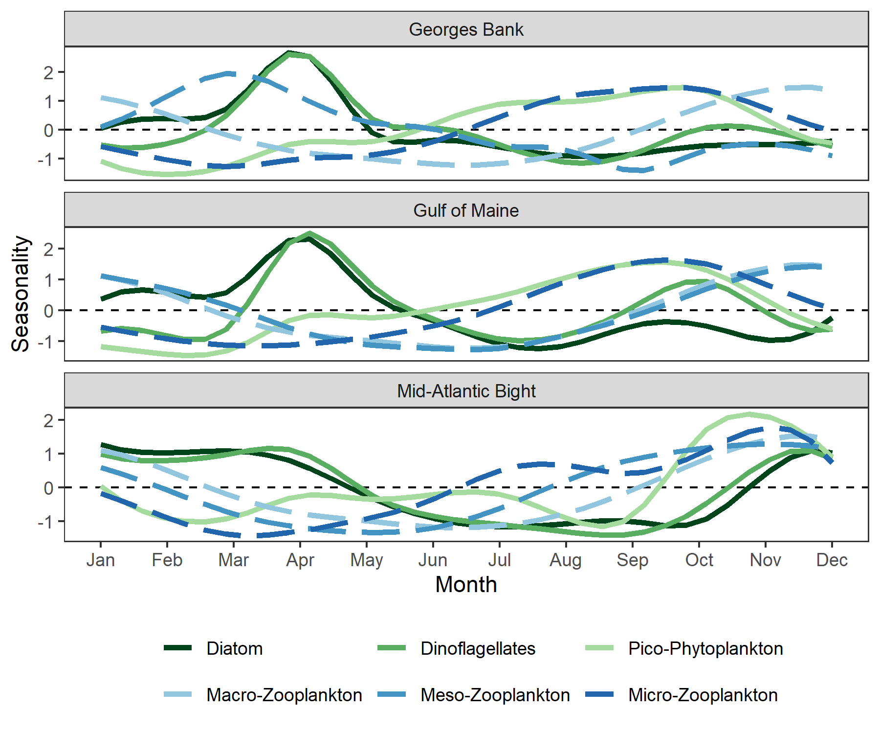

*Figure 9: Monthly standardized mean seasonality for lower-trophic functional groups (colors) in each ecological region (panels). Standardization makes the magnitude of seasonal cycles between groups not comparable, but the relative timing between and within functional groups is preserved. Zooplankton are represented by blue dashed lines and phytoplankton by green solid lines.*

*4.2.2 Planktivores and Benthos*

Planktivore species’ spatial distribution is directly specified (Figure S2), but community composition partially emerges from the spatial distributions and abundance of predators and prey. The majority of NEUSv2’s planktivore biomass was attributable to Atlantic herring (*Clupea harengus*), Atlantic menhaden (*Brevoortia tyrannus*), Atlantic mackerel (*Scomber scombrus*), and butterfish (*Peprilus triacanthus*; Table 1). The mean annual biomass for these dominant planktivore species during the post-spinup period was within 0.5 to 2 times available assessment data, with the exception of butterfish (3.6 times higher). In NEUSv2, planktivores primarily consumed diatoms and zooplankton. Planktivore consumption uses a Hollings Type II functional response with an availability parameter for each prey, such that trophic interactions are higher with increased spatial overlap with prey. As such, elevated mesozooplankton biomass in the GOM are the result of lower planktivores biomass compared to other regions (Figure 8). Additionally, NEUSv2 planktivores spawning (using a Bevorton-Holt parameterization) occurs on a predetermined date each year, so seasonal cycles in biomass are not emergent properties.

The benthos functional groups exhibited negligible seasonal patterns and showed a steady increase in biomass within the MAB and a decrease in GB (Figure 8). GOM benthos biomass stabilized early in the simulation. On a domain-wide scale, benthos species’ biomass fell within the 5% annual threshold thus passing the stability criteria. Benthos species in NEUSv2, despite being large consumers of deposited phytoplankton, did not show the seasonal responsiveness as seen in zooplankton. This difference was likely due to the temporal lag between surface production and deposition.

*4.3 Grazing*

The average daily consumption (*Cp*) of diatoms, dinoflagellates, and picoplankton by all grazers was 5%, 9.9%, and 15.6%, respectively. Unconsumed phytoplankton either remain in the surface layer until they are overwritten by the next time step forcing, sink or mix into deeper pelagic layers, deposit into the sediment layer (in one-layer boxes), or lyse and are converted into detrital pools. Of the phytoplankton that were deposited, NEUSv2 does not classify them as detritus until they are consumed or converted by sediment bacteria. A box-level mean of 0.5% of diatoms and 0.3% of dinoflagellates are deposited from the deepest pelagic layer at each time step. Picoplankton are not parameterized to sink in NEUSv2 due to their small size. Deposition rates in NEUSv2 are entirely dependent on sinking rate and layer thickness.

Much of the benthic invertebrate diets consist of these deposited phytoplankton, which constitutes 92% of the cumulative grazing. On average, benthic grazers consume 90% of the passively deposited diatoms, resulting in net accumulation in some boxes. In the pelagic food web, 56% of diatoms consumption is performed by zooplankton and 43% by planktivores (Table 2). Nearly all pelagic picoplankton consumption was performed by microzooplankton, which is the intentional result of gape size limitations of fish groups and a simplified lower trophic food web. The amount of grazing attributable to each function group is consistent over time, with only slight seasonal fluctuations.

*Table 2: The percentage of phytoplankton consumed by each grazer functional group (*Gg,p*) both when including and excluding benthic grazers.*

|  |  |  |  |  |  |  |
| --- | --- | --- | --- | --- | --- | --- |
|  | **All Grazing** | | | **Pelagic Grazing** | | |
| Functional Group | Diatoms | Dinoflagellates | Pico-  phytoplankton | Diatoms | Dinoflagellates | Pico-  phytoplankton |
| *Planktivores* | 3.5% | - | - | 43.3% | - | - |
| *Shrimp* | <0.1% | - | - | 0.4% | - | - |
| *Dinoflagellates* | - | <0.1% | <0.1% | - | <0.1% | <0.1% |
| *Macrozooplankton* | 1.9% | <0.1% | - | 22.1% | 4.5% | - |
| *Mesozooplankton* | 2.9% | <0.1% | - | 34.1% | 0.4% | - |
| *Microzooplankton* | - | 2.1% | 96.1% | - | 95.1% | 99.9% |
| *Benthos* | 91.6% | 97.8% | 3.9% |  |  |  |
| *Other* | <0.1% | <0.1% | <0.1% | 0.1% | <0.1% | <0.1% |

5.Discussion

To our knowledge, NEUSv2 is the first Atlantis model to successfully force primary production with ocean color data. As such, we feel a description of the observations and hurdles involved in these new methods would be beneficial to other modelers. These lessons learned can be found in the supplementary material.

**5.1 Model Performance**

All NEUSv2 phytoplankton, zooplankton, planktivore, and benthic functional groups met our baseline calibration criteria of persistence and time series stability with the exception of sea scallops, which had a relative increase of 7% per year. Since phytoplankton were forced, it was critical that zooplankton and planktivore groups mirrored observed behavior in order to ensure that primary production was distributed throughout the simulated food web. Temporal analyses of northeast shelf zooplankton communities suggest a shift in community composition occurring around 2010 (Morse et al., 2017), and while individual zooplankton species are not resolved, a breakpoint analysis of NEUSv2 total zooplankton biomass time series shows a change in time series slope in 2013. The general agreement between NEUSv2 and COPEPOD’s total zooplankton carbon mass indicates that NEUSv2 was capable of reproducing a plausible zooplankton population biomass. However, COPEPOD does not possess the spatial or temporal resolution required to perform a statistical comparison. A potential source of error in zooplankton biomass may result from the error inherent in the phytoplankton forcing. Turner et al. (2021) describe a correlation coefficient (absolute bias) between *in situ* and modeled of 0.7 (0.04) for micro-phytoplankton concentrations and 0.58 (0.08) for nano- and pico-phytoplankton. This bias represents about 10% of typical diatom and picoplankton concentrations in NEUSv2 suggesting low impact of model results.

Due to their small size and pelagic distribution, the planktivores simulated in NEUSv2 are not as well sampled compared to demersal species in regional trawl surveys, resulting in a high degree of uncertainty regarding population level biomass. However, planktivore species’ assessment biomass estimates from the NOAA StockSmart database show that NEUSv2 values well within an order of magnitude of assessment. As additional aspects of higher trophic level calibration are outside the scope of this study, we deem planktivores to be at an acceptable level. Possible causes for discrepancies with assessment data are the inclusion of juveniles in NEUSv2 species biomass. Anecdotally, we observed that during calibration, there was a strong coupling between macrozooplankton biomass and the equilibrium biomass for herring and mackerel. Despite some inconsistencies between simulated planktivores and assessments, it is clear that the forced primary production is being transferred into higher trophic levels in the pelagic food web through zooplankton and not entirely dependent on benthic grazers (i.e. some alternative stable state).

**5.2 Model Configuration**

One eventual goal of NEUSv2 is to develop ecosystem-level projections under different climate and management scenarios. Thus it is important that NEUSv2 reproduces ecosystem processes on the spatial and temporal scales relevant for this goal. A notable tradeoff in Atlantis model design is between the scope of the simulated processes and the scale that those processes can be practically resolved (Link et al., 2010). This tradeoff is evident in NEUSv2’s box definitions and the translation of forcing data. Atlantis models generally define box geometry based on bathymetry with partial consideration of regional habitat types, biological communities, fisheries independent survey strata, and fisheries management areas. As such, NEUSv2 is intentionally not designed to capture fine details of physical processes. Circulation was particularly difficult to capture due NEUSv2’s relatively few number of faces, and NEUSv2 captured circulation best when faces were arranged perpendicular to major currents. One method for improving NEUSv2’s ability to capture more circulation features would be to increase the number of simulated boxes, yet this would result in a large increase in run time (Audzijonyte et al., 2017). Thus, i t is unlikely that any slight increase in box count with no other changes would improve NEUSv2’s ability to simulate higher trophic levels and improve its applicability to management. Additionally, the NEUSv2 simulated food web is less reliant on horizontal advection than Atlantis models with dynamic primary production as forced phytoplankton are not influenced by nutrient fluxes and other state variables (temperature and salinity) are forced themselves.

The coarse vertical resolution of NEUSv2 also had unexpected consequences on biological processes. Single-layer boxes result in equal access to phytoplankton for both pelagic and epibenthic grazers. To prevent the forced phytoplankton from subsidizing the epibenthos, the clearance rates and availability of phytoplankton to epibenthic filter feeders were reduced below what would be typically observed. Though if reduced too greatly, bivalve filter feeders may shift to detritus-dominated diets when faced with limited access to phytoplankton, and while some of the regions shellfish may require some detritus in their diets (Munroe et al., 2013), the majority of their consumption should be phytoplankton (Both et al., 2020; Cranford and Grant, 1990). We recommend a careful assessment of the dynamics on any single-layer boxes and a contextual evaluation of whether a two-layer box (i.e. a separate benthic boundary and euphotic layer) would be advantageous.

**5.4 Consequences of phytoplankton forcing**

Phytoplankton forcing in Atlantis results in a one-way coupling between the satellite derived size class product and NEUSv2. As a consequence, at each time step biomass values are entirely overwritten, regardless of the intermediate grazing. The result is that even when grazing is high, local depletions in phytoplankton do not persist into further time steps. The goal of proper calibration is then to replicate the magnitude and seasonality of *in situ* grazing present at the time of satellite measurements, despite the lack of bottom-up feedbacks on zooplankton groups.

In end-to-end ecosystem models, zooplankton act as a bridge between biogeochemistry and higher trophic levels (HTLs; Rose et al., 2010), and allowing two-way feedbacks between HTLs and zooplankton can be essential for obtaining realistic HTL population dynamics (Holt et al., 2014; Travers et al., 2009). Atlantis models typically simulate all LTL dynamics including the underlying biogeochemistry only requiring physical forcing (Fulton et al., 2005), but at the coarse resolution of Atlantis boxes. Despite NEUSv2 breaking the bidirectional feedbacks between phytoplankton and zooplankton, it retains two-way interactions between zooplankton and HTLs. Integrating the higher resolution satellite products instead of using Atlantis’ traditional primary producer dynamics, provides NEUSv2 with information on smaller-scale phytoplankton processes (i.e. coastal and upwelling effects) as well as drives seasonality in LTL processes at the expense of phytoplankton-zooplankton coupling. Given that that the ultimate objective of NEUSv2 is to inform HTL resource management, this tradeoff does not reduce the applicability of NEUSv2.

Due to the one-directional phytoplankton-zooplankton interactions and data limitations, grazers in NEUSv2 rarely experience food limitation even when competition is high. Without careful tuning of clearance and growth rates, forced primary producers can effectively subsidize grazer production resulting in unrealistically high population biomass. To compensate for the lack of bottom-up control on zooplankton, a quadratic mortality term was applied for all zooplankton functional groups. Quadratic mortality in zooplankton typically represents intra-guild consumption (Mitra et al., 2014; Ohman et al., 2002), but also acts as a top-down control on zooplankton biomass and ultimately grazing. The result was more stable biomass time series with the tradeoff of potentially losing some responsiveness to bottom-up signals (Kearney et al., 2013).

Though top-down controls are built into the phytoplankton forcing, they are independent from NEUSv2 dynamics. This works well for an Atlantis hindcast, as the forced phytoplankton act as a historical driver for the system. However, if the model was run as a projection, different phytoplankton forcing sources would need to be incorporated past the present day. In this case, NEUSv2 would have to be coupled to a comparable regional biogeochemical model projection (Drenkard et al., 2021).

6. Conclusion

One of the major goals of NEUSv2 was to integrate existing data products in order to both ensure that critical patterns in environmental variables and primary production were captured and to build a foundation for the simulated ecosystem that would allow for comparisons to regional fisheries management and assessments. We have found that the coarse resolution of NEUSv2 adequately captures seasonal and spatial characteristics of high-resolution GLORYS12V1 temperature and salinity as well as the high-resolution ocean color derived phytoplankton size classes. This new phytoplankton forcing method allowed for a simplified bottom-up calibration strategy and drove the seasonality of the simulated ecosystem. With forced phytoplankton, NEUSv2 was capable of reproducing plausible population sizes of zooplankton and planktivores. Despite removing the bi-directional feedback between phytoplankton and zooplankton, NEUSv2 planktivores and other HTLs were able to respond to zooplankton dynamics. Overall, we recommend this forcing method for other Atlantis models.

If high model skill is required for lower trophic or nutrient processes, calibrating Atlantis’ internal biogeochemical processes or coupling Atlantis to a nutrient, phytoplankton, and zooplankton (NPZ) model may be more appropriate (Kearney et al., 2012; Stock et al., 2014). Atlantis’ lower trophic level sub-models are comprehensive enough to capture essential dynamics within the system (Fulton et al., 2005; Travers et al., 2007) but operate on a much coarser resolution than other more specialized NPZ model products. Additionally, requirements for global parameters with a coarse resolution necessitate non-tactical objectives (Fulton, 2010) than even when upscaling a regionally-tuned NPZ model. Forcing phytoplankton with an observation-based product will require additional coupling to other biogeochemical simulations to run NEUSv2 as a projection.

While additional features are needed in order for NEUSv2 to be used directly as a strategic management tool (e.g. improve realism in socio-economics and HTL dynamics), it is well-suited for exploring ecosystem-level impacts to changes in functional group biomass, fishing pressure, and life history parameters with regards to community composition and population dynamics. NEUSv2 also provides a hypothesis testing framework for ecological indicators, ecological sensitivity to particular functional groups, and application of alternative physical and primary production models. Future work will aim to improve model skill of higher trophic levels and improve species’ responsiveness to environmental variables.

7. Acknowledgements

This research was performed while the author held an NRC Research Associateship award at NOAA’s Northeast Fisheries Science Center. We would also like to thank I. Kaplan and B. Fulton for their thoughtful suggestions and advice.

8. References

Adams, C., 2017. Butterfish 2017 Stock Assessment Update.

Atlantic States Marine Fisheries Commission (ASMFC), 2020. ASMFS Stock Assessment Overview: Atlantic Menhaden.

Audzijonyte, A., Gorton, R., Kaplan, I., Fulton, E.A., 2017. Atlantis User’s Guide Part I: General Overview, Physics and Ecology.

AVHRR Pathfinder Version 5.3 Level 3 Collated (L3c) Global 4km Sea Surface temperature for 1981-Present, 2018.

Bastille, K., Hardison, S., Lucey, S., Schillaci, C., Walden, J., Fratantoni, P., Caracappa, J., DePiper, G., Vogt, B., Pellerin, C., Vogel, R., Zhang, Q., Hyde, K., Chen, Z., Colburn, L., Weng, C., Gaichas, S., Smith, L., Beet, A., Gamble, R., Saba, V., Wuenschel, M., Roskar, G., Orphanides, C., Saba, G., Walsh, H., Friedland, K., White, T., Shield, G., Gangopadhyay, A., Silva, A., Lyons, D., Morse, R., 2021. Technical Documentation, State of the Ecosystem 2021.

Bossier, S., Nielsen, J.R., Almroth-Rosell, E., Höglund, A., Bastardie, F., Neuenfeldt, S., Wåhlström, I., Christensen, A., 2021. Integrated ecosystem impacts of climate change and eutrophication on main Baltic fishery resources. Ecol. Modell. 453. https://doi.org/10.1016/j.ecolmodel.2021.109609

Bossier, S., Palacz, A.P., Nielsen, J.R., Christensen, A., Hoff, A., Maar, M., Gislason, H., Bastardie, F., Gorton, R., Fulton, E.A., 2018. The Baltic sea Atlantis: An integrated end-to-end modelling framework evaluating ecosystem-wide effects of human-induced pressures, PLoS ONE. https://doi.org/10.1371/journal.pone.0199168

Brooks, D.A., 1985. Vernal Circulation in the Gulf of Maine. J. Geophys. Res. 90, 4687–4705.

Casey, K.S., Tess, B.B., Cornillon, P., Evans, R., 2010. The Past, Present, and Future of the AVHRR Pathfinder SST Program, in: Barale, V., Gower, J.F.R., Alberotanza, L. (Eds.), Oceanography from Space: Revisisted. Dordrecht: Springer Netherlands, pp. 273–87. https://doi.org/https://doi.org/10.1007/978-90-481-8681-5_16.

Cheung, W.W.L., Frölicher, T.L., Asch, R.G., Jones, M.C., Pinsky, M.L., Reygondeau, G., Rodgers, K.B., Rykaczewski, R.R., Sarmiento, J.L., Stock, C., Watson, J.R., 2016. Building confidence in projections of the responses of living marine resources to climate change. ICES J. Mar. Sci. 73, 1283–1296. https://doi.org/10.1093/icesjms/fsv250

Chin, T., Vazquez-Cuervo, J., Armstrong, E.M., 2017. A Multi-scale High Resolution Analysis of Global Sea Surface Temperature. Remote Sens. Environ. 200, 154–169. https://doi.org/https://doi.org/10.1016/j.rse.2017.07.029

CMEMS, 2018. GLORYS12V1 - Global Ocean Physical Reanalysis Product. E.U. Copernicus Marine Service Information.

Drenkard, E.J., Stock, C., Ross, A.C., Dixon, K.W., Adcroft, A., Alexander, M., Balaji, V., Bograd, S.J., Butenschön, M., Cheng, W., Curchitser, E., Lorenzo, E. Di, Dussin, R., Haynie, A.C., Harrison, M., Hermann, A., Hollowed, A., Holsman, K., Holt, J., Jacox, M.G., Jang, C.J., Kearney, K.A., Muhling, B.A., Buil, M.P., Saba, V., Sandø, A.B., Tommasi, D., Wang, M., 2021. Next-generation regional ocean projections for living marine resource management in a changing climate. ICES J. Mar. Sci. 78, 1969–1987. https://doi.org/10.1093/icesjms/fsab100

ECCO Consortium, Fukumori, I., Wang, O., Fenty, I., Forget, G., Heimback, P., Ponte, R.M., 2015. ECCO Central Estimate (/i Version 4 Release 4 /i).

Frankignoul, C., de Coëtlogon, G., Joyce, T.M., Dong, S., 2001. Gulf Stream Variability and Ocean–Atmosphere Interactions*. J. Phys. Oceanogr. 31, 3516–3529. https://doi.org/10.1175/1520-0485(2002)031<3516:GSVAOA>2.0.CO;2

Fulton, E.A., Link, J.S., Kaplan, I.C., Savina-rolland, M., Johnson, P., Horne, P., Gorton, R., Gamble, R.J., Smith, A.D.M., Smith, D.C., 2011. Lessons in modelling and management of marine ecosystems : the Atlantis experience. Fish Fish. 12, 171–188. https://doi.org/10.1111/j.1467-2979.2011.00412.x

Hansen, C., Nash, R.D.M., Drinkwater, K.F., Hjøllo, S.S., 2019. Management Scenarios Under Climate Change – A Study of the Nordic and Barents Seas. Front. Mar. Sci. 6, 1–13. https://doi.org/10.3389/fmars.2019.00668

Hirata, T., Hardman-Mountford, N.J., Brewin, R.J.W., Aiken, J., Barlow, R., Suzuki, K., Isada, T., Howell, E., Hashioka, T., Noguchi-Aita, M., Yamanaka, Y., 2011. Synoptic relationships between surface Chlorophyll-*a* and diagnostic pigments specific to phytoplankton functional types. Biogeosciences 8, 311–327. https://doi.org/10.5194/bg-8-311-2011

Hodgson, E.E., Kaplan, I.C., Marshall, K.N., Leonard, J., Essington, T.E., Busch, D.S., Fulton, E.A., Harvey, C.J., Hermann, A., McElhany, P., 2018. Consequences of spatially variable ocean acidification in the California Current: Lower pH drives strongest declines in benthic species in southern regions while greatest economic impacts occur in northern regions. Ecol. Modell. 383, 106–117. https://doi.org/10.1016/j.ecolmodel.2018.05.018

Hyndman, R., Khandakar, Y., 2008. Automatic Time Series Forecasting: The Forecast Package for R. J. Stat. Softw. 26, 1–22.

Ihde, T.F., Townsend, H.M., 2017. Accounting for multiple stressors influencing living marine resources in a complex estuarine ecosystem using an Atlantis model. Ecol. Modell. 365, 1–9. https://doi.org/10.1016/j.ecolmodel.2017.09.010

JPL MUR MEaSUREs, 2015. GHRSST Level 4 MUR Global Foundation Sea Surface Temperature Analysis (V4.1). https://doi.org/https://doi.org/10.5067/GHGMR-4FJ04

Kaplan, I.C., Hansen, C., Morzaria-Luna, H.N., Girardin, R., Marshall, K.N., 2020. Ecosystem-Based Harvest Control Rules for Norwegian and US Ecosystems. Front. Mar. Sci. 7, 1–15. https://doi.org/10.3389/fmars.2020.00652

Kaplan, I.C., Marshall, K.N., 2016. Ecosystem Models for Management Applications. ICES J. Mar. Sci. 73, 1715–1724.

Kearney, K., Stock, C., Sarmiento, J., 2013. Amplification and attenuation of increased primary production in a marine food web. Mar. Ecol. Prog. Ser. 491, 1–14. https://doi.org/10.3354/meps10484

Kearney, K.A., Stock, C., Aydin, K., Sarmiento, J.L., 2012. Coupling planktonic ecosystem and fisheries food web models for a pelagic ecosystem: Description and validation for the subarctic Pacific. Ecol. Modell. 237–238, 43–62. https://doi.org/10.1016/j.ecolmodel.2012.04.006

Lentz, S.J., 2008. Observations and a Model of the Mean Circulation over the Middle Atlantic Bight. J. Phys. Oceanogr. 38, 1203–1221. https://doi.org/10.1175/2007JPO3768.1

Link, J.S., Fulton, E.A., Gamble, R.J., 2010. The northeast US application of ATLANTIS : A full system model exploring marine ecosystem dynamics in a living marine resource management context. Prog. Oceanogr. 87, 214–234. https://doi.org/10.1016/j.pocean.2010.09.020

Link, J.S., Gamble, R.J., Fulton, E.A., 2011. Atlantis: Construction, Calibration, and Application of an Ecosystem Model with Ecological Interactions, Physiographic Conditions, and Flee Behavior, NOAA Tech Memo NMFS NE-218.

Morel, A., Berthon, J.-F., 1989. Surface pigments, algal biomass profiles, and potential production of the euphotic layer: Relationships reinvestigated in view of remote-sensing applications. Limnol. Oceanogr. 34, 1545–1562. https://doi.org/10.4319/lo.1989.34.8.1545

Moriarty, R., O’Brien, T.D., 2013. Distribution of mesozooplankton biomass in the global ocean. Earth Syst. Sci. Data 5, 45–55. https://doi.org/10.5194/essd-5-45-2013

Morse, R.E., Friedland, K.D., Tommasi, D., Stock, C., Nye, J., 2017. Distinct zooplankton regime shift patterns across ecoregions of the U.S. Northeast continental shelf Large Marine Ecosystem. J. Mar. Syst. 165, 77–91. https://doi.org/10.1016/j.jmarsys.2016.09.011

Nilsen, I., Kolding, J., Hansen, C., Howell, D., 2020. Exploring Balanced Harvesting by Using an Atlantis Ecosystem Model for the Nordic and Barents Seas. Front. Mar. Sci. 7. <https://doi.org/10.3389/fmars.2020.00070>

NOAA Fisheries. 2022. Stock SMART data records. Retrieved from www.st.nmfs.noaa.gov/stocksmart. 03/02/2022.

Northeast Fisheries Science Center, 2021. Northest Atlantic Mackerel, 2021 Management Track Assessemnt Report.

Northeast Fisheries Science Center, 2018. 65th Northeast Regional Stock Assessment Workshop (65th SAW) Assessment Summary Report.

Northeast Fisheries Science Center, 2011. Northeast Regional Stock Assessment Workshop (51st SAW) Assessment Report.

Ohman, M.D., Runge, J.A., Durbin, E.G., Field, D.B., Niehoff, B., 2002. On birth and death in the sea. Hydrobiologia 480, 55–68. https://doi.org/10.1023/A:1021228900786

Ortega-Cisneros, K., Cochrane, K.L., Fulton, E.A., Gorton, R., Popova, E., 2018. Evaluating the effects of climate change in the southern Benguela upwelling system using the Atlantis modelling framework. Fish. Oceanogr. 27, 489–503. https://doi.org/10.1111/fog.12268

Pettigrew, N.R., Churchill, J.H., Janzen, C.D., Mangum, L.J., Signell, R.P., Thomas, A.C., Townsend, D.W., Wallinga, J.P., Xue, H., 2005. The kinematic and hydrographic structure of the Gulf of Maine Coastal Current. Deep Sea Res. Part II Top. Stud. Oceanogr. 52, 2369–2391. https://doi.org/10.1016/j.dsr2.2005.06.033

Sathyendranath, S., Brewin, R., Brockmann, C., Brotas, V., Calton, B., Chuprin, A., Cipollini, P., Couto, A., Dingle, J., Doerffer, R., Donlon, C., Dowell, M., Farman, A., Grant, M., Groom, S., Horseman, A., Jackson, T., Krasemann, H., Lavender, S., Martinez-Vicente, V., Mazeran, C., Mélin, F., Moore, T., Müller, D., Regner, P., Roy, S., Steele, C., Steinmetz, F., Swinton, J., Taberner, M., Thompson, A., Valente, A., Zühlke, M., Brando, V., Feng, H., Feldman, G., Franz, B., Frouin, R., Gould, R., Hooker, S., Kahru, M., Kratzer, S., Mitchell, B., Muller-Karger, F., Sosik, H., Voss, K., Werdell, J., Platt, T., 2019. An Ocean-Colour Time Series for Use in Climate Studies: The Experience of the Ocean-Colour Climate Change Initiative (OC-CCI). Sensors 19, 4285. https://doi.org/10.3390/s19194285

Sathyendranath, S., Jackson, T., Brockmann, C., Brotas, V., Calton, B., Chuprin, A., Clements, O., Cipollini, P., Danne, O., Dingle, J., Donlon, C., Grant, M., Groom, S., Krasemann, H., Lavender, S., Mazeran, C., Mélin, F., Müller, D., Regner, P., Steinmetz, F., Steele, C., Swinton, J., Valente, A., Zühlke, M., Feldman, G., Franz, B., Frouin, R., Werdell, J., Platt, T., 2020. ESA Ocean Colour Climate Change Initiative (Ocean Colour cci): Global chlorophyll-a data products gridded on a sinusoidal projection, Version 4.2.

Stock, C.A., Dunne, J.P., John, J.G., 2014. Global-scale carbon and energy flows through the marine planktonic food web : An analysis with a coupled physical – biological model. Prog. Oceanogr. 120, 1–28. https://doi.org/10.1016/j.pocean.2013.07.001

Turner, K.J., Mouw, C.B., Hyde, K.J.W., Morse, R., Ciochetto, A.B., 2021. Optimization and assessment of phytoplankton size class algorithms for ocean color data on the Northeast U.S. continental shelf. Remote Sens. Environ. 267, 112729. https://doi.org/10.1016/j.rse.2021.112729

Wood, S.N., 2017. Generalized Additive models: An Introduction with R, 2nd ed. Chapman and Hall/CRC.

Zhang, S., Stock, C.A., Curchitser, E.N., Dussin, R., 2019. A Numerical Model Analysis of the Mean and Seasonal Nitrogen Budget on the Northeast U.S. Shelf. J. Geophys. Res. Ocean. 124, 2969–2991. https://doi.org/10.1029/2018JC014308

9. Supplemental Figures

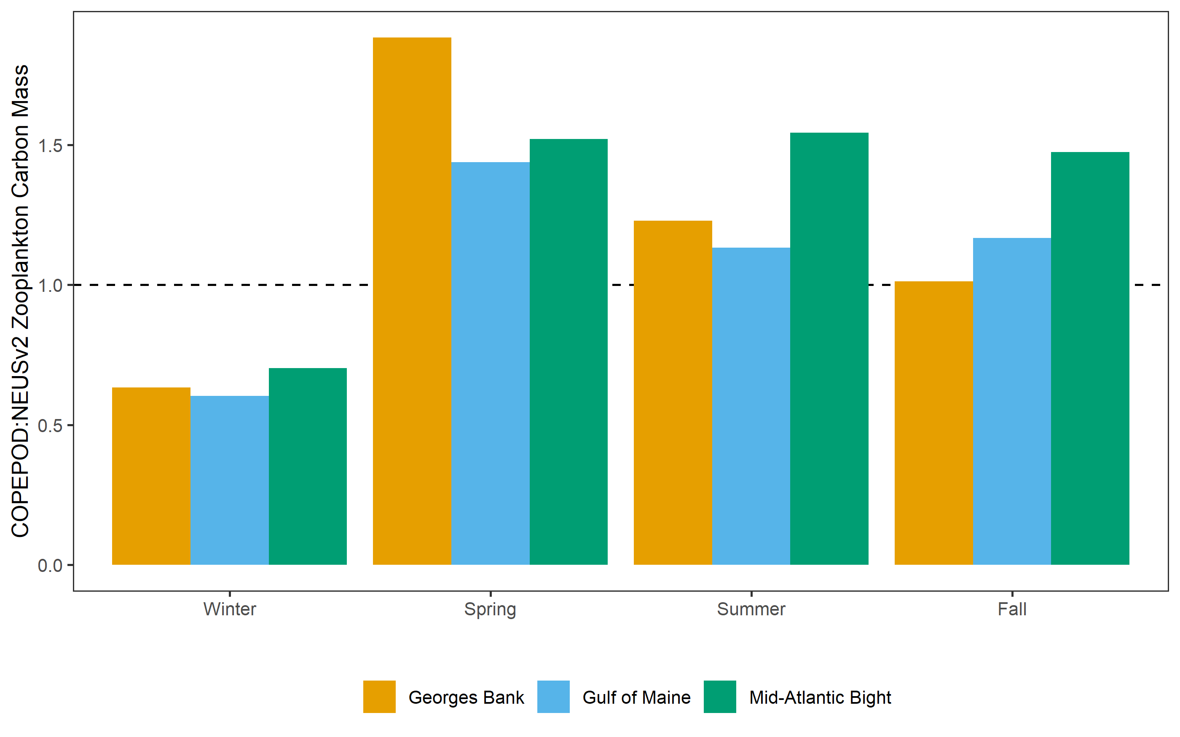

*Figure S1: The ratio of COPEPOD to NEUSv2 total zooplankton carbon mass. Data are aggregated by season and EPU (colors).*

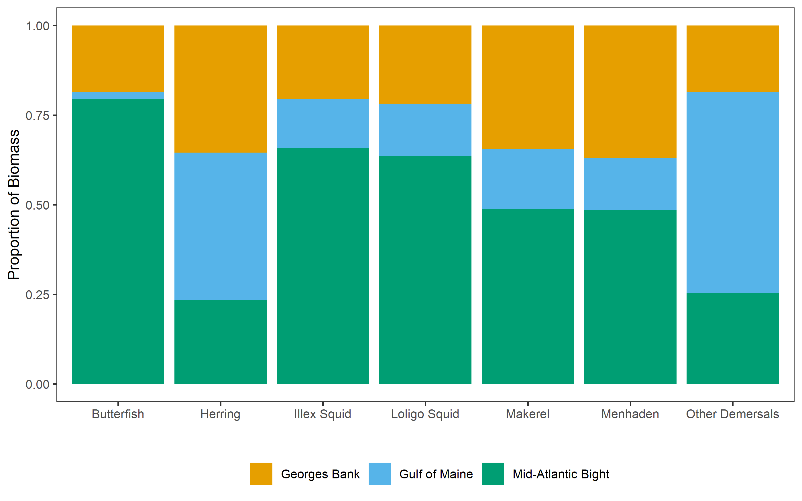

*Figure S2: Summary of the predefined spatial distribution of each planktivorous fish species by EPU. These are based on the FXXX_SY parameters in Atlantis’ biology parameter file. At each time step, spatial distributions of each species are weighted towards these fixed proportions to prevent unrealistic aggregations or drifting.*

*Table S1: Mean of daily bias for each variables and for each NEUSv2 box and layer. Level 1 is 0-50m, level 2 is 50–120m, and level 3 is 120-300m. Phytoplankton groups (diatoms, dinoflagellates, and picoplankton) are only forced in the surface level and have bias units of mg N m-3.*

|  |  |  |  |  |  |  |  |  |  |
| --- | --- | --- | --- | --- | --- | --- | --- | --- | --- |
|  | Level 1 | | | Level 1 | Level 2 | Level 3 | Level 1 | Level 2 | Level 3 |
| Box | Diatom | Dinoflagellate | Picoplankton | Salinity (PSU) | | | Temperature (oC) | | |
| 1 | 0.27 | 0.05 | 0.07 | <±0.01 | - | - | -0.06 | - | - |
| 2 | 0.06 | 0.01 | 0.04 | -0.02 | - | - | -0.06 | - | - |
| 3 | 0.02 | <±0.01 | 0.03 | -0.02 | -0.01 | <±0.01 | -0.06 | -0.05 | -0.01 |
| 4 | 0.42 | 0.11 | 0.05 | <±0.01 | - | - | <±0.01 | - | - |
| 5 | 0.08 | 0.01 | 0.03 | -0.01 | <±0.01 | - | -0.01 | -0.01 | - |
| 6 | 0.03 | <±0.01 | 0.01 | -0.01 | -0.01 | - | -0.01 | -0.01 | - |
| 7 | 0.15 | 0.04 | 0.02 | <±0.01 | - | - | <±0.01 | - | - |
| 8 | 0.20 | 0.04 | 0.04 | <±0.01 | <±0.01 | - | <±0.01 | -0.01 | - |
| 9 | 0.07 | 0.01 | 0.01 | -0.01 | -0.01 | - | -0.01 | -0.01 | - |
| 10 | 0.17 | 0.03 | 0.03 | <±0.01 | <±0.01 | - | -0.01 | <±0.01 | - |
| 11 | 0.03 | <±0.01 | 0.01 | <±0.01 | <±0.01 | <±0.01 | <±0.01 | <±0.01 | <±0.01 |
| 12 | 0.01 | <±0.01 | <±0.01 | <±0.01 | <±0.01 | - | -0.01 | <±0.01 | - |
| 13 | 0.05 | 0.01 | <±0.01 | <±0.01 | - | - | <±0.01 | - | - |
| 14 | 0.02 | 0.00 | 0.01 | <±0.01 | <±0.01 | <±0.01 | -0.01 | -0.01 | <±0.01 |
| 15 | 0.03 | 0.00 | 0.02 | <±0.01 | <±0.01 | - | <±0.01 | <±0.01 | - |
| 16 | 0.04 | 0.00 | 0.01 | <±0.01 | <±0.01 | <±0.01 | <±0.01 | <±0.01 | <±0.01 |
| 17 | 0.17 | 0.04 | 0.01 | <±0.01 | <±0.01 | - | <±0.01 | <±0.01 | - |
| 18 | 0.15 | 0.03 | 0.01 | <±0.01 | <±0.01 | - | <±0.01 | <±0.01 | - |
| 19 | 0.03 | <±0.01 | 0.01 | <±0.01 | <±0.01 | <±0.01 | <±0.01 | <±0.01 | <±0.01 |
| 20 | 0.01 | <±0.01 | 0.01 | <±0.01 | <±0.01 | <±0.01 | <±0.01 | <±0.01 | <±0.01 |
| 21 | 0.01 | <±0.01 | 0.01 | <±0.01 | <±0.01 | <±0.01 | <±0.01 | <±0.01 | <±0.01 |
| 22 | 0.01 | <±0.01 | <±0.01 | <±0.01 | <±0.01 | - | <±0.01 | <±0.01 | - |